SAMPLE SORTING AND STORAGE WITHIN SURGERY PRIOR TO COLLECTION
Box Colour | Sample Tube Colour | Tests | Storage
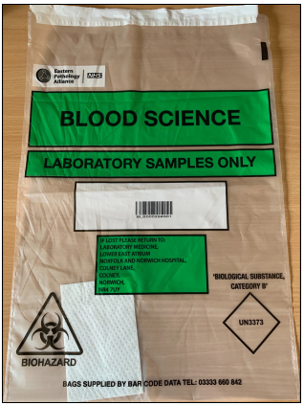  Blood Sciences  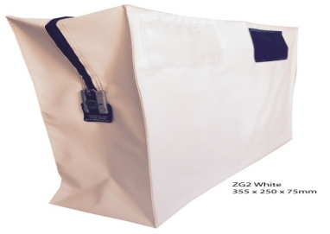  INR Samples 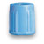  Only in White Bag | 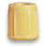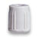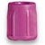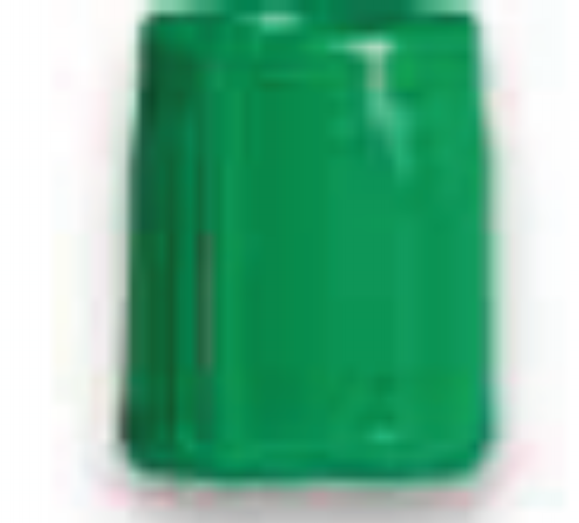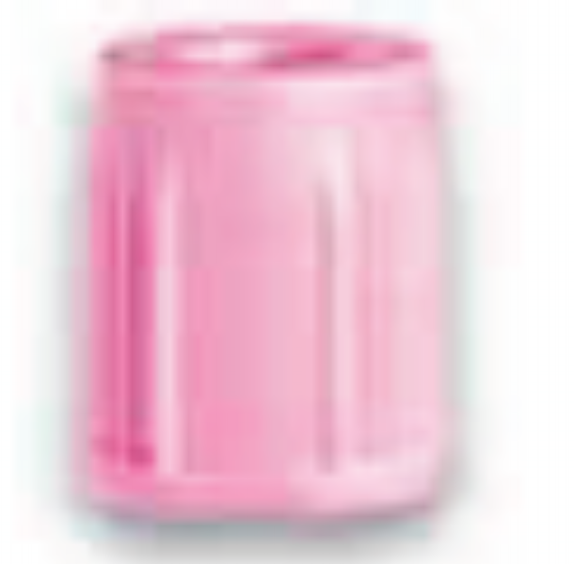Blood Tubes  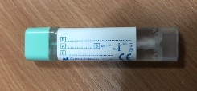 FIT Tube  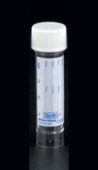 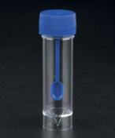 Calprotectin Tube  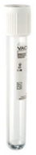  Urine Tube  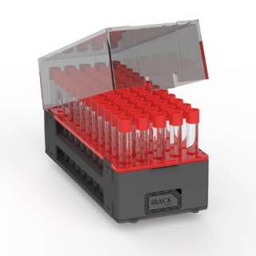  Indexor Rack/s | All samples for Clinical Biochemistry, Haematology, Immunology and Coagulation  Indexor Rack  Including Urines for Albumin/Creatinine ratio plus Protein/Creatinine ratio.  FIT Faecal Samples  Calprotectin Faecal Samples  Blood Groups  Also ALL Antenatal Clinic Samples  Pregnancy Tests. | Storage of samples taken on same day as collection MUST be kept at ROOM TEMP prior to collection.  DO NOT PLACE  - on window sill  - in direct sunlight  - near a radiator  - on floor if you have under floor heating.  Samples which are to be stored overnight place in fridge at approx. 4ºc.
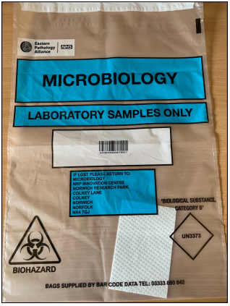  Microbiology | 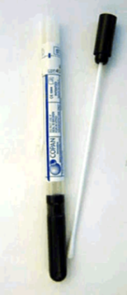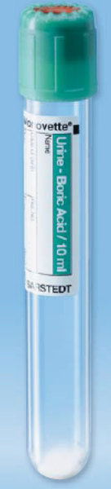 | Urine samples for Culture and Sensitivity.  Faecal Samples for Culture and Sensitivity.  All swabs.  Skin/Hair/Nails for mycology.  Sputum samples for Culture & Sensitivity (MC&S)  Blood Samples for Serology | All Microbiology samples should be stored in fridge at 4ºc. If this is not convenient during the day before collection samples can be kept at room temp using criteria as above.  Overnight, samples should be placed in fridge at approx. 4ºc.
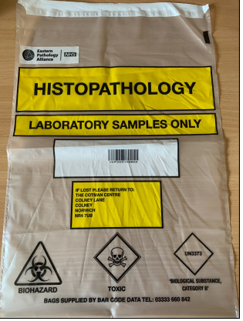  Cytology and Histopathology |   Plus  Histology Samples in Formalin  and  Non Gynae Samples | LBC Cervical and  Non Gynae Samples  E.G. Urines, Sputa, Fluids, FNA samples  Histology samples in Formalin  For consumables phone 01603 286957 | LBC and Histology samples in formalin samples must at all times be left at room temp but again taking into consideration criteria above.  All Non-Gynae samples which are to be stored overnight place in fridge at approx. 4ºc.
For further advice please call 01603 286929

