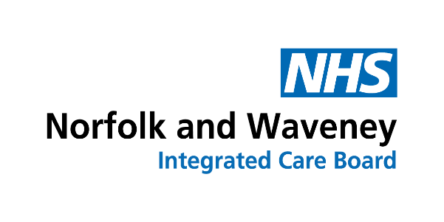
Scheduled Monthly Payments
Frequently Asked Questions
____________________________________________________

Below is an example schedule: -

Fees are paid up to the end of this month, along with any backdated amounts or adjustments due

.
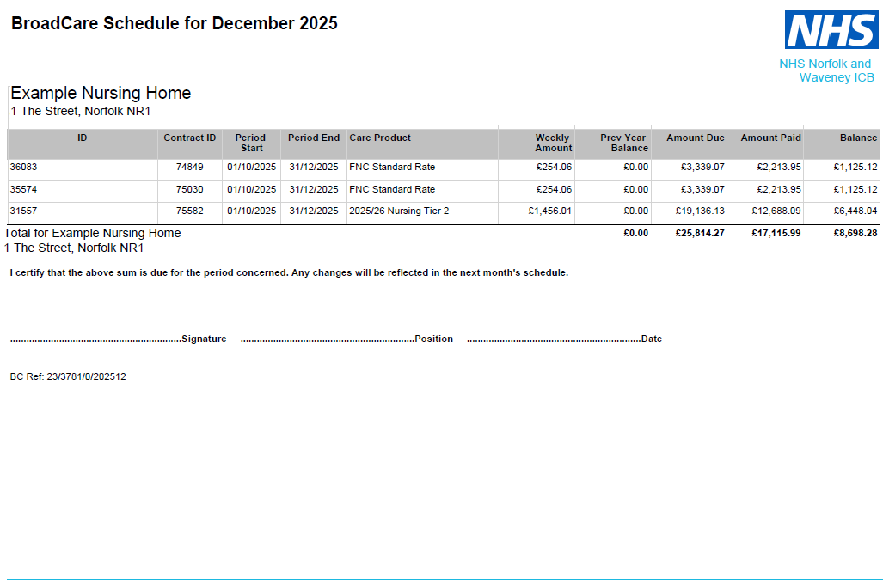
Use this area to note any queries / amendments or discrepancies
Provider Signature Position/Job Title dd mm yy
Patient ID (NFK / GYW number) and the contract/agreement the payment relates to
Period Start = date of first scheduled payment.
Period End = end of month fees paid up to
Balance = payment amount per patient and total amount paid overall

- The Care Product column indicates the type of package the payment relates to (eg Funded Nursing Care, Nursing Care, 1:1 Care)

- The Weekly Amount is the weekly package cost that the payment has been based on.

- The columns for Previous Year, Amount Due, Amount Paid can be disregarded; they are ongoing figures for information only.

- The Balance column is the amount paid per patient with the total at the bottom.

- I have only received the SBS Remittance Advice.

SBS release their remittance advice on the day the payment is generated (payment should be on your account within 2 working days)
The full schedule breakdown is sent separately by NWICB.

- Do I have to raise an invoice for a scheduled payment package?

No – please do not issue an invoice for a package that is paid by schedule.

When an agreement is issued the covering email will advise the payment method and if an invoice is required. (for example, currently we still require invoices for Discharge to Assess packages.)

- I have raised an invoice for a scheduled payment package – what do I do?

We appreciate that providers still need to raise invoices for accounting purposes however since the payment will be made by schedule, these should be retained internally to allocate funds once received.
If an invoice is received for a package that is paid by schedule it will be rejected and removed from NWICB’s ledger.

It would be appreciated if invoices are not submitted to SBS unless requested to avoid additional work.

- I have not received an expected payment for an individual patient.

Payments cannot be made until the Agreement (CASA) relating to the package has been signed and returned and internal system activation by the ICB has been completed.
Please note we endeavour to complete package activation as soon as possible.

If the agreement has not been returned, or returned recently, this is the most likely reason for non-payment.

If the package is under a Discharge to Assess arrangement you will need to issue an invoice – these packages are currently not included in scheduled payments.

If none of the above apply, please add a note to the schedule before returning it.

- I have been overpaid / underpaid

An adjustment will be made on the following scheduled payment run should there be an over or under payment following a change in the package (eg the patient passed away, the package closed or the fees changed).

If you believe an adjustment is required, please add a note to the schedule before returning it.

- When will payments be made

Scheduled payments are generated at the beginning of each month, and fees are paid in arrears. Due to the rigorous checks that we undertake, we aim to complete the schedule payments by the end of the third week of each month but payments may be received sooner than this.

