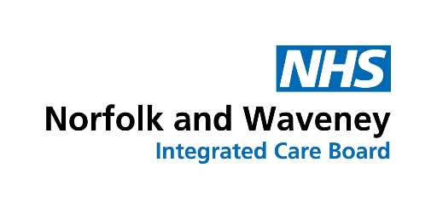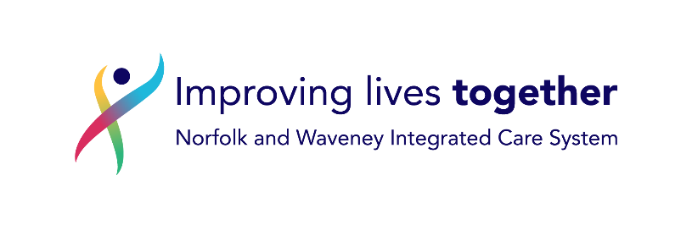

Date

Name

Address

NHS Norfolk and Waveney ICB

Floor 8 - County Hall

Martineau Lane

Norwich

NR1 2DH

Dear

**Important information about your medication used to treat Type-2 Diabetes Mellitus**

NHS Norfolk and Waveney ICB regularly reviews medicines being prescribed to ensure that local doctors are using safe and effective products which are also good value. From time-to-time lower cost alternatives to existing higher priced medicines become available. Where the active ingredient is in the same class of drug, for most people it is safe to change over to a different manufacturer’s version of a medicine.

You are currently taking Xxxxxxxxxx {INSERT strength} tablets. Nationally, the cost of another type of medication in this class of medicines has come down. Sitagliptin is now the best value alternative for the NHS to prescribe.

The next time you collect your prescription you will notice that your usual prescription has been changed to:

**Sitagliptin** {INSERT strength} tablets– Take **ONE** daily

Sitagliptin contains the same class of ingredient as your previous medicine. The strength (milligrams) is different to that of your previous medicine; please be assured that the affect in the body is the same.

**Please use up all your previous medicine before starting this new version.** We do not expect you to notice any difference when your prescription is changed. However your practice will continue to monitor your condition and response to treatment as before.

Any decision to change prescribing is not taken lightly; it is our responsibility to provide the best value for money for all our patients. To meet that duty, we need to make sure we commission cost-effective prescribing which will have the greatest impact on the largest number of people.

If you have any questions regarding this change then please contact our ContactUS team on 01603 595857 or email [nwicb.contactus@nhs.net](mailto:nwicb.contactus@nhs.net)

Yours sincerely

**Dr Andrew Douglass MBBS MRCGP**

**Specialty Advisor for Prescribing and Elective Recovery**

**NHS Norfolk and Waveney ICB**