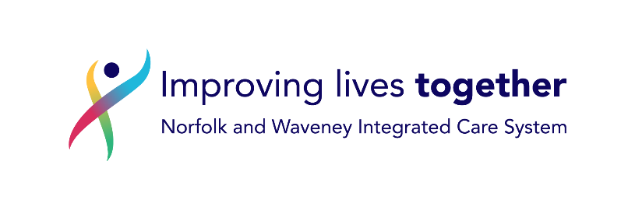

**GP Response Form: Request to prescribe in Primary Care DECLINED**

|  |  |  |  |
| --- | --- | --- | --- |
| Hospital Number: |  | NHS Number: |  |
| First name: |  | Surname: |  |
| Address: |  | DoB: |  |
| GP: |  | Surgery: |  |
| **REF: *MEDICATION(S) / APPLIANCE(S)*** | | | |

|  |  |  |  |  |  |  |  |
| --- | --- | --- | --- | --- | --- | --- | --- |
| Dear Colleague,  Thank you for your prescribing request to General Practice. | | | | | | | |
| We are not able to proceed with issuing a prescription against the request, due to the reason(s) below: | | | | | | |
|  |  | | | | | | |
|  | Insufficient patient identifiers | |  | Preparation unavailable | | | |
|  | No indication present | |  | TAG* Guidance: Hospital Only / Red & Double Red / Black | | | |
|  | No prescriber name present | |  | Not to be prescribed in primary care (FP10) | | | |
|  | Prescriber name not legible | | Non-formulary | | |  | |
|  | Dose / duration not specified | |  | TAG Shared Care prescribing request not in line with SCA - [Shared Care Agreements - Knowledge NoW](https://nwknowledgenow.nhs.uk/content-category/prescribing-pharmacy-and-medicines-optimisation/therapeutic-advisory-group-tag/shared-care-agreements/) | | | |
|  | Request illegible | |  | Other – give details: | | | |
|  |  | |  |
|  |  | |  |  | | | |
| Signed: | | ……………………………………. | Date: | |  | | |
| Name: | |  | | | | | |
| Please contact me / any member of the practice on       if you have any queries. | | | | | | | |

*Therapeutic Advisory Group (TAG), Drug & Therapeutic Committee (DTC)