**How to enrol Multi-Factor Authentication (MFA) Guide v1**

1. Please log in to your NHSmail account via the portal - [Sign In (nhs.net)](https://fs.nhs.net/adfs/ls/?wtrealm=urn%3aPROD.Portal.NHSMail&wctx=WsFedOwinState%3dTuwKlzTWRo7LziYaujdsSLi4kozx7jU6Mog2sLmk25Ba9DW3NoDOozrDRqVg8IFXJtpqUHCePEFEsIq8MAiqJCgXM5KYNy02foU5NCBHENkQ6BH-vtLOSsZ_8DLDJcK9imR7QIRz1vDcG6lZPz_YAA&wa=wsignin1.0)
2. Once logged in – Click ‘Profile’ in the navigation bar at the top of the screen.

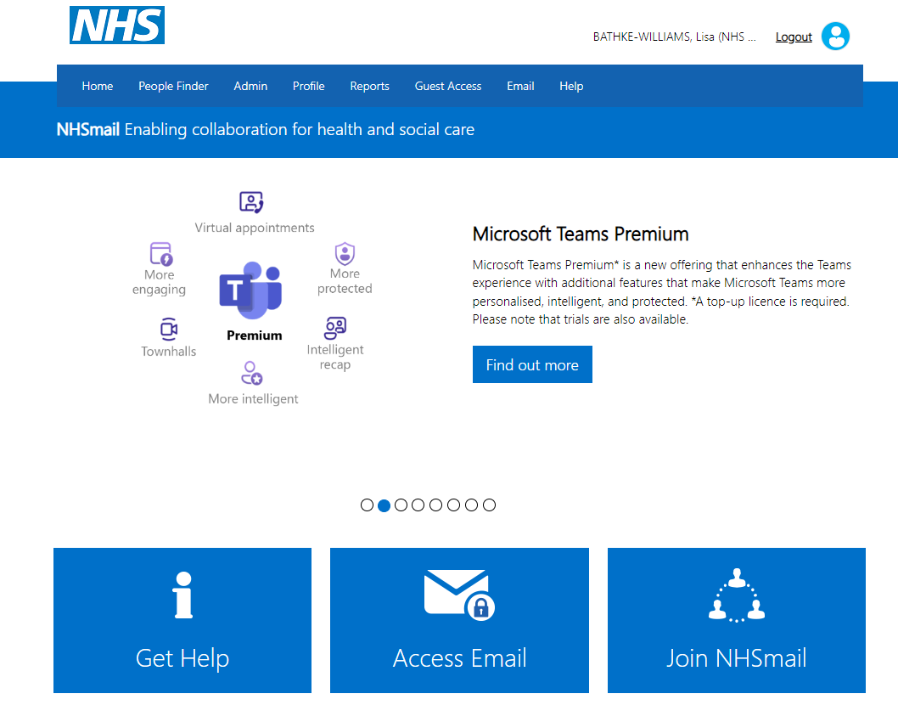

1. Select ‘My Profile’ from the drop-down menu.

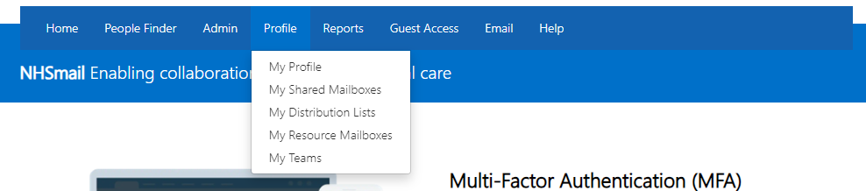

1. From ‘My Profile’ page, select ‘Self- Service’.

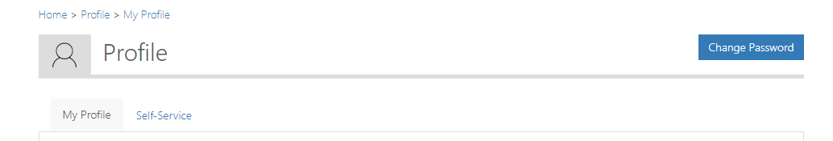

1. Select ‘Self- enrol’ for MFA.
2. Click ‘Confirm’ to enable MFA.
3. The following success message will be displayed: ‘Success: MFA enabled successfully for [nhsmailaccount@nhs.net](mailto:nhsmailaccount@nhs.net)



.