**Authenticate using Text message authentication Guide V1**

1. Please log in to your NHSmail account via the portal - [Sign In (nhs.net)](https://fs.nhs.net/adfs/ls/?wtrealm=urn%3aPROD.Portal.NHSMail&wctx=WsFedOwinState%3dTuwKlzTWRo7LziYaujdsSLi4kozx7jU6Mog2sLmk25Ba9DW3NoDOozrDRqVg8IFXJtpqUHCePEFEsIq8MAiqJCgXM5KYNy02foU5NCBHENkQ6BH-vtLOSsZ_8DLDJcK9imR7QIRz1vDcG6lZPz_YAA&wa=wsignin1.0)
2. If you have enabled MFA on your account, you will be directed to the next steps. If not, please see ‘How to enrol onto Multi-Factor Authentication (MFA) Guide’ first.
3. Select at the bottom of the box ‘I want to set up a different method’ to add another option to authenticate your account.

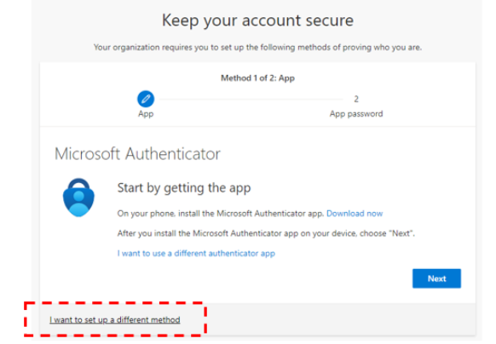

.

1. A box with a drop list with different options to register for MFA will appear on the screen.

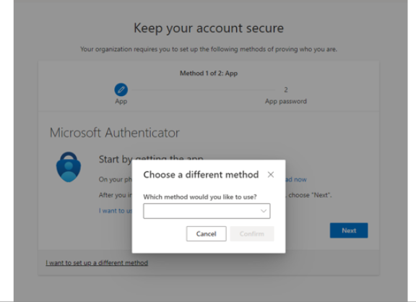

1. This page allows you to choose an alternative option to authenticate your NHSmail account. Select ‘Phone’ option. (Note: The use of the office phone option is not supported by NHSmail. This option is available to users as Multi-factor Authentication is an off-the-shelf feature that cannot be customised.)

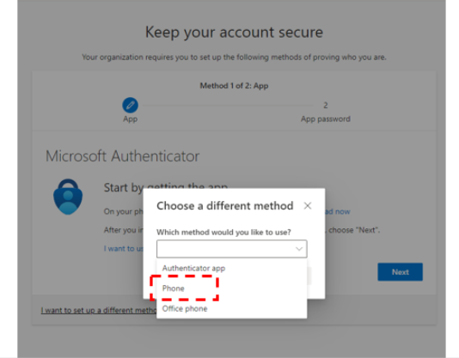

1. Click ‘Confirm’ to continue the register process. **(Note: This phone number is your preferred contact method and is not linked to the number listed in your NHSmail Portal profile.)**

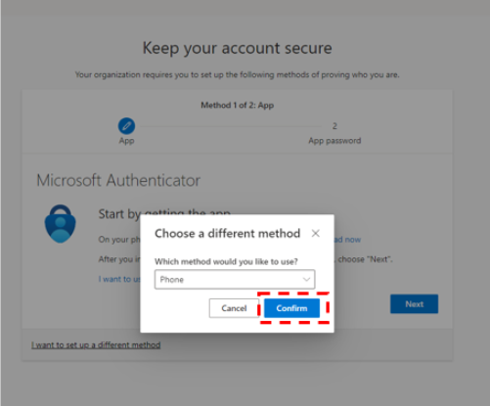

1. Select your country code from the country options and enter the mobile phone number you would like to use, select ‘Text me a code’ as your authentication method and click ‘Next.’ **(Note: Mobile numbers used to register for an NHSmail account must be UK based.)**

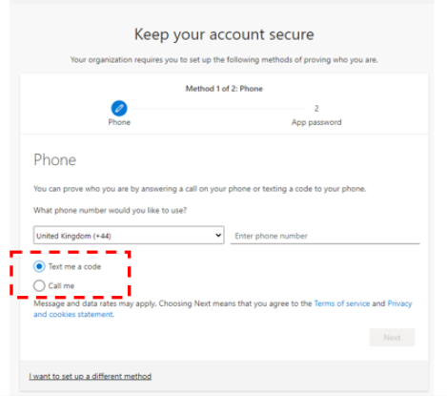

1. Microsoft will send an authentication text code, please check your mobile phone for the six-digit number text code (SMS.) **Note: It is not expected that you will be charged to use this service as no messages will be sent during 2-step verification. However, SMS charges may apply if you try to access your account from outside the UK (incurring roaming charges.)**

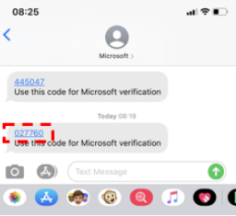

1. Enter the six-digit text code received by mobile phone into the text box provided and click ‘Next’ to proceed.

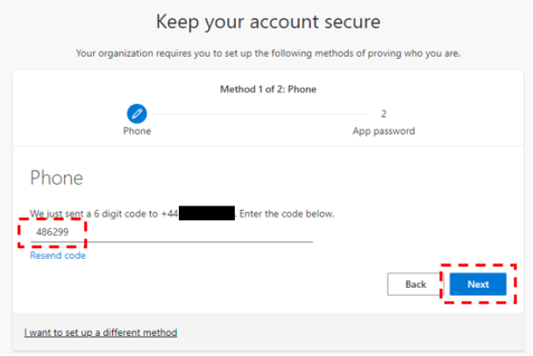

1. When the code is validated, this message will appear on the screen. Click ‘Next’ to be taken to the next page.

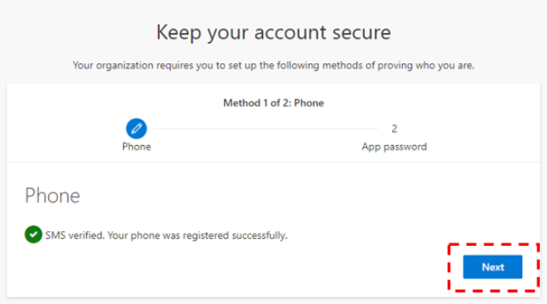

1. Insert a password name of at least 8 characters and then click ‘Next.’ **Note: The App password is required for legacy applications that MFA does not support.**

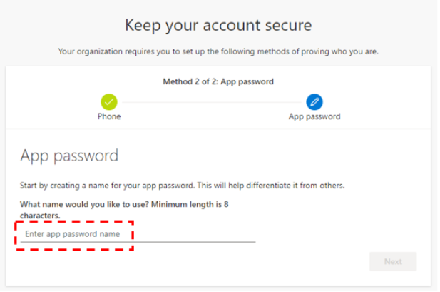

1. After creating a password name, you will be provided with a key password – store this password in a safe place and click ‘done.’

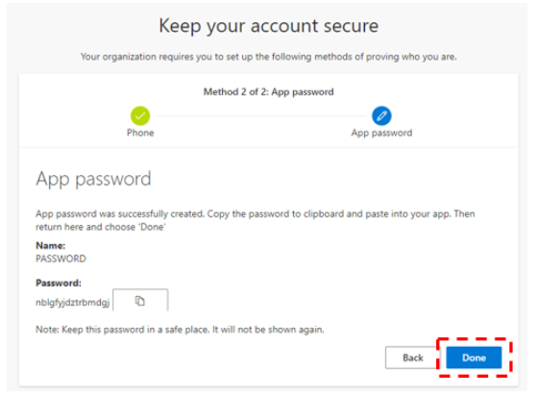

1. This message will confirm that you have finished your Microsoft Authenticator App set up. Click ‘Done’ and you will be taken to the application initially selected.

