**Authenticate using Microsoft Authenticator App Guide V1**

1. Please log in to your NHSmail account via the portal - [Sign In (nhs.net)](https://fs.nhs.net/adfs/ls/?wtrealm=urn%3aPROD.Portal.NHSMail&wctx=WsFedOwinState%3dTuwKlzTWRo7LziYaujdsSLi4kozx7jU6Mog2sLmk25Ba9DW3NoDOozrDRqVg8IFXJtpqUHCePEFEsIq8MAiqJCgXM5KYNy02foU5NCBHENkQ6BH-vtLOSsZ_8DLDJcK9imR7QIRz1vDcG6lZPz_YAA&wa=wsignin1.0)
2. If you have enabled MFA on your account, you will be directed to the next steps. If not, please see ‘How to enrol onto Multi-Factor Authentication (MFA) Guide’ first.
3. Select ‘Click me to enrol for Multi-Factor Authentication’ to proceed.

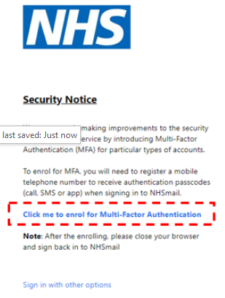

.

1. You will be redirected to the following page, select ‘Next’ to start the MFA process.

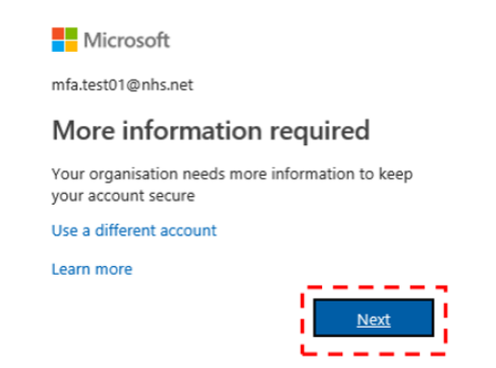

1. Click ‘Download Now’ to open a new window with the QR code to download the Microsoft Authenticator App

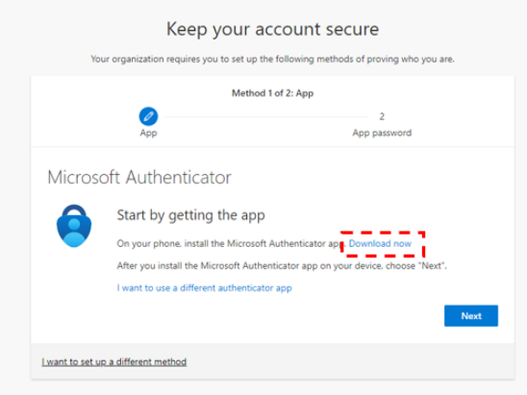

1. Scan the QR code that is displayed with the camera on your mobile phone. To do this open your camera and pointing the camera at the QR code. Then, tap on the pop-up banner or the QR code icon that appears on your mobile screen. This will direct you to download the Microsoft Authenticator App on your mobile.

(If you are using Android use the QR code on the left and if you are using IOS (Apple/iPhone) scan the QR code on the right.

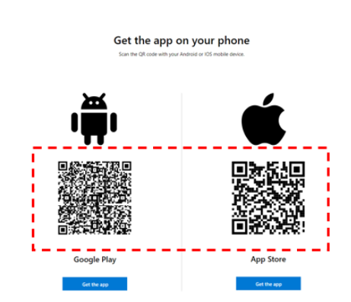

1. Click ‘Get’ or ‘Install’ to download the Microsoft Authenticator App on your mobile phone and then click ‘Open.’

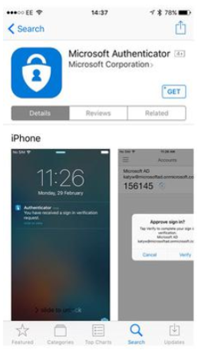

1. Click ‘Open’ to launch the Microsoft Authenticator app on your mobile phone.

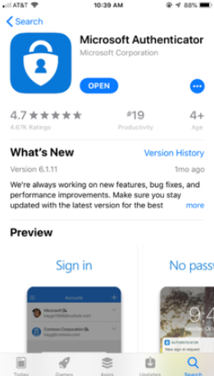

1. After downloading the Microsoft Authenticator App on your mobile phone click ‘Next.’

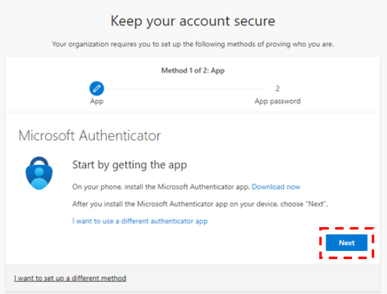

1. Open the Microsoft Authenticator App on your mobile phone to set up and then click ‘Next.’

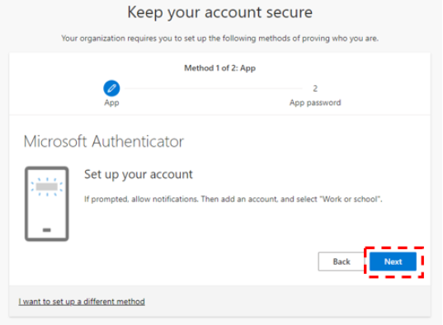

1. On this screen, open your Microsoft Authenticator App on your mobile device and follow the next steps.

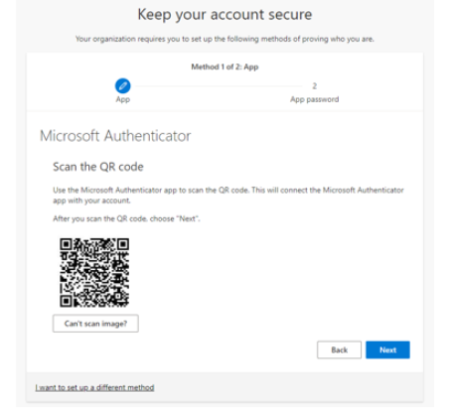

1. Tap the ‘+’ or ‘+Add account’ icon to add an account.

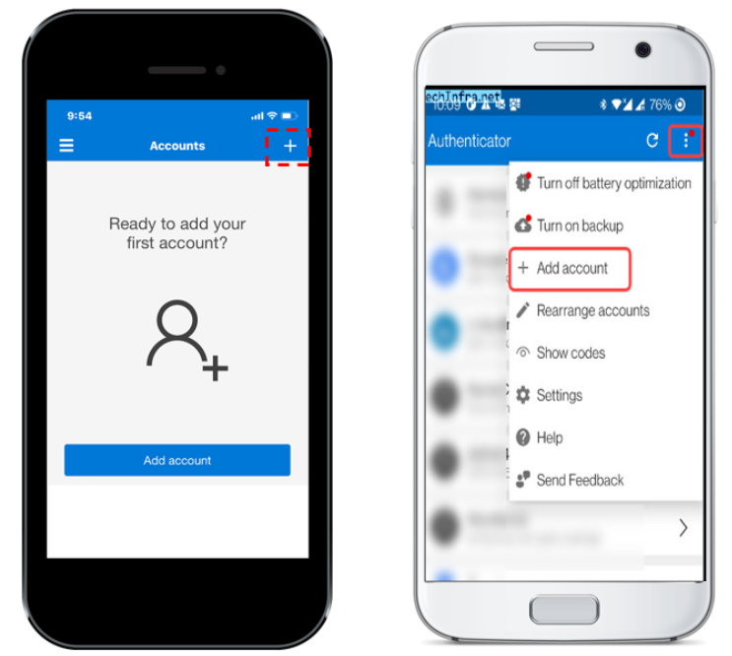

1. Select ‘Work or school account’.

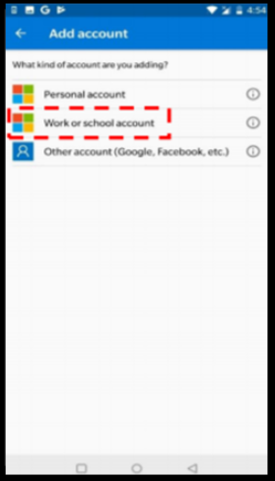

1. A pop-up box will appear on your Microsoft Authenticator App screen, click ‘Scan QR code.’

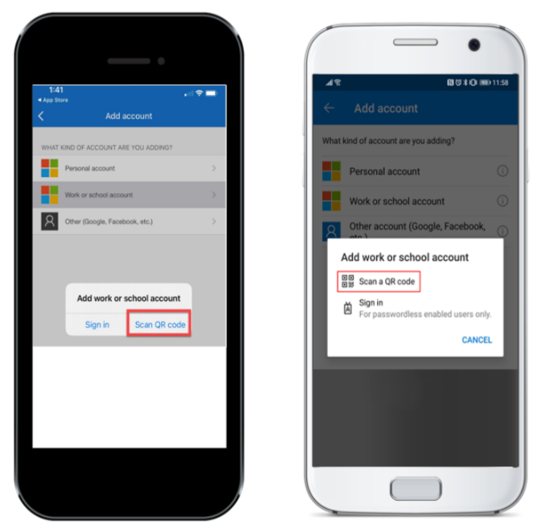

1. On the Microsoft Authenticator App screen, a QR code reader will appear. Point the mobile device to the screen and scan the QR code.

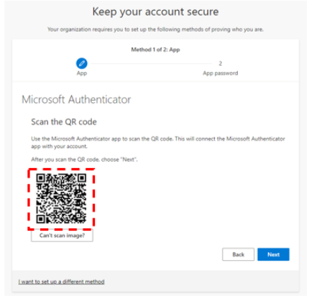

1. Click ‘Next’ to be directed to the next step and continue the enrolment process.

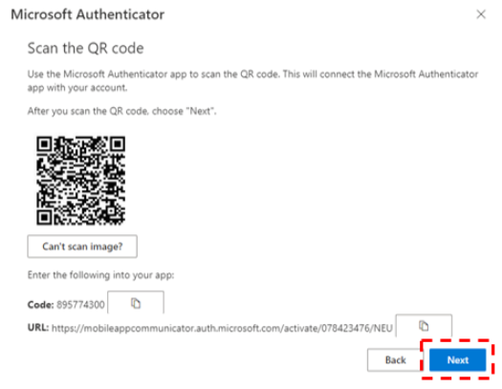

1. Following the approval on the Microsoft Authenticator App this screen will appear – no action needed in this time.

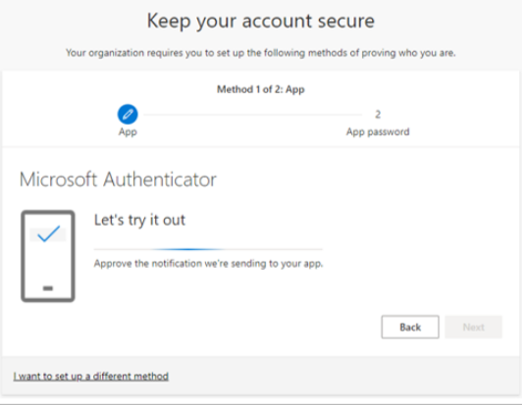

1. A pop-up box will appear on your Microsoft Authenticator App screen, select ‘Approve.’

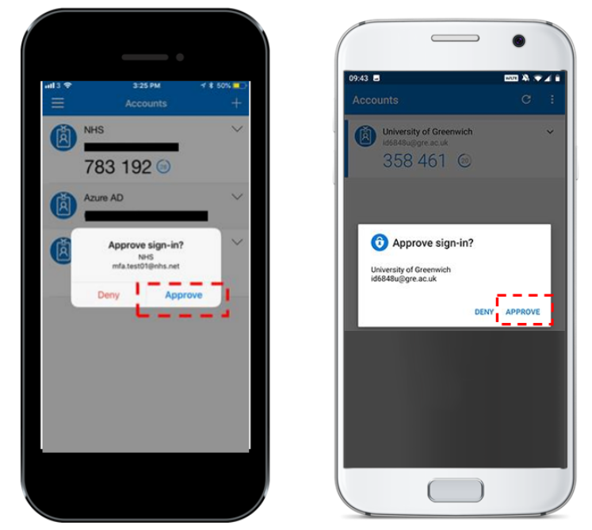

1. After approving the notification on your mobile phone app, you will receive the following message ‘Notification approved’, click ‘Next.’

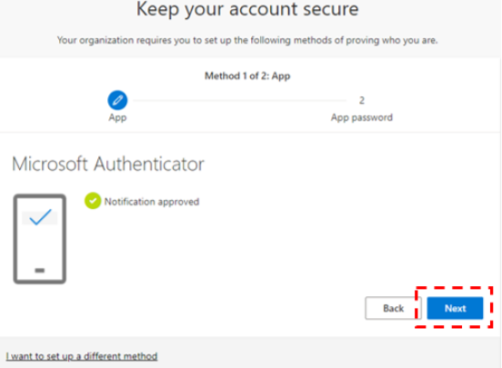

1. Insert a password name of at least 8 characters and then click ‘Next.

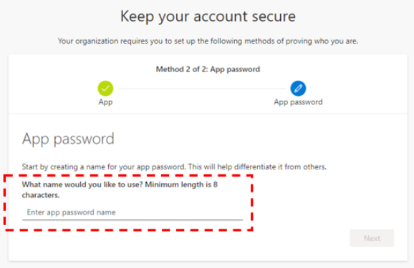

1. After creating a password name, you will be provided with a key password – store this password in a safe place and click ‘Done.’

