SOP012: Appliance Contractor Nomination
Purpose | The process of issuing prescriptions to an appliance contractor nomination.
Scope | This applies to patients with a nominated appliance contractor only, not to patients who wish for their appliances to be sent to the same pharmacy as their regular medications. Appliance contractors are another supplier for items such as stoma, catheters etc.
For the use of | Enter your text here

A patient may choose to nominate an appliance contractor to deliver some of their prescription items, such as catheter products, stoma products or oral nutritional supplements.
- When processing a prescription for appliance items, click on the nomination icon to check if they have an appliance nomination.

- If no appliance contractor is nominated, process appliance items along with any other items requested in the usual way following SOP001.
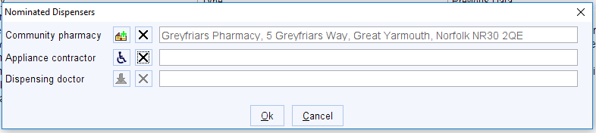

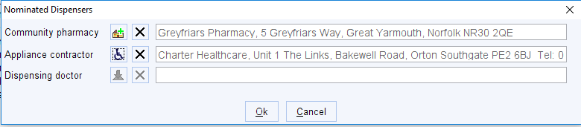
- If the patient has a nominated appliance contractor - When issuing appliance prescriptions, you will need to issue these separately to their other medications to avoid items being sent to the incorrect nomination.
- Highlight the appliances requested by the patient and click on the issue icon.

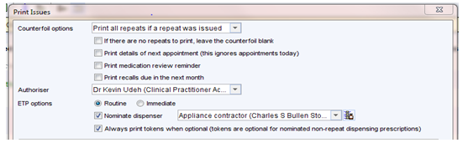
- Click on the save icon and then check the nomination is the patient’s appliance nomination.
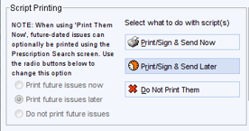
- Check the script printing is set correctly to Print/Sign & Send Later and click ok.

For a dispensing patient at a dispensing practice – Check the script printing is set correctly to Print/Sign & Send Later and the Dispensing side is set to Do Not Dispense and click ok. <Remove if this is not applicable to your surgery>

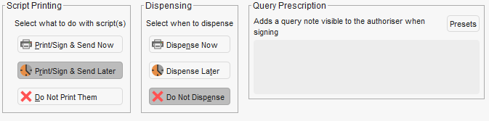

Check the Dispensing side is set to Do Not Dispense
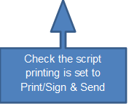

- If the patient is requesting other non-appliance items, go back into the patients record and process following SOP001. These can then be sent to the patients nominated pharmacy.

Version Control
Date | Version Number | Change Made
29/04/2024 | v0.1 | New SOP

