SOP009: Requests for medications not on repeat (acute)
Purpose | A guide for processing requests for medications which are not on the patient’s repeat template.
Scope | This SOP is for processing medications that are not on the repeat template and can be found in the ‘Medication’ section of the clinical tree. These are commonly referred to as Acute requests.
For the use of | Enter your text here

- Patient requests medications not on the current repeat template.

- Follow SOP001 - Repeat Template on how to request repeat medication first (do not click save).

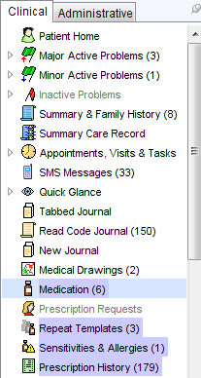
- Click on Medication in the clinical tree.
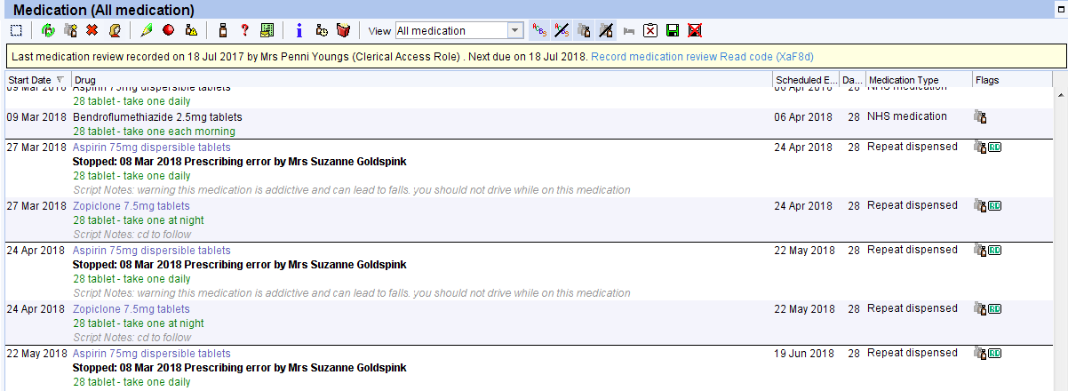
- Click on the drop-down box in view.
- Select Summary to view all the medications the patient has been prescribed.

- Click on the medication the patient wishes to order to highlight. Check this is due to be ordered (you can double click on the medication to see the quantity issued).

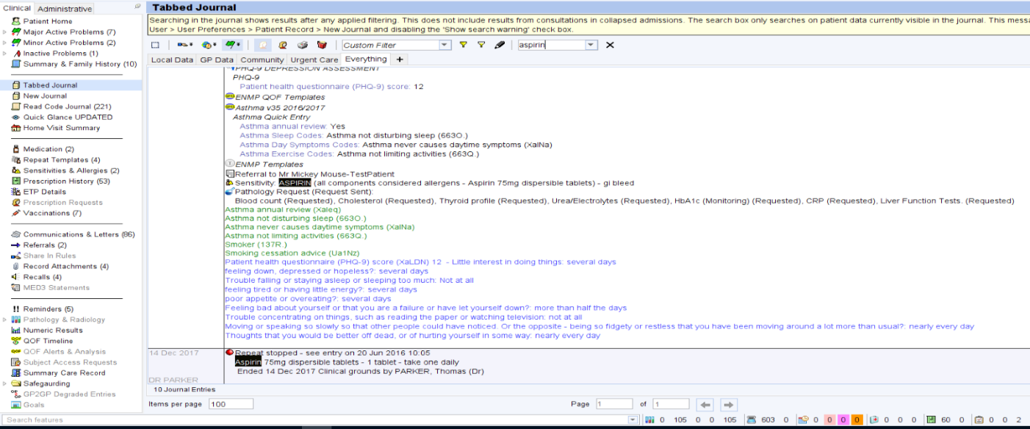
- Search for this medication in the Tabbed Journal/New Journal. Type into the search bar and press enter to show all entries for this medication.

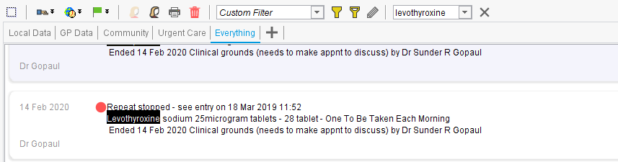
- Look specifically for repeat stopped messages.

- If the requested item has been stopped <Insert your process here>

(POD process was to not request stopped items and advise patient to contact the surgery)

- If the medication has not been issued in the last 12 months
<Insert your process here>

- If the medication is ok to be requested, you can request this in two ways:

- Via a Task
- Via a Patient Request

To request medication via a Task:
- Click on TASK

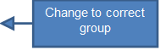
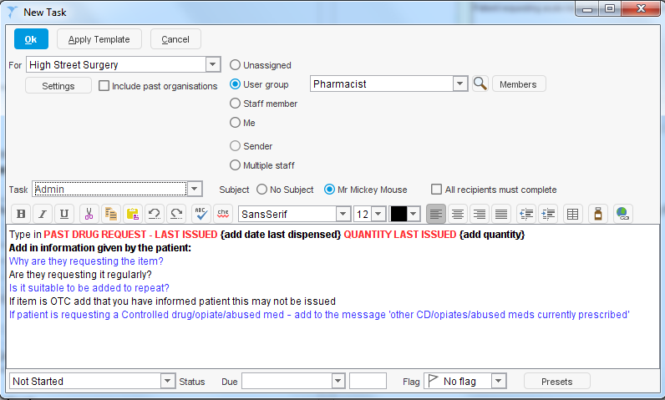
- Change to relevant task group where necessary and type in all relevant
PAST DRUG REQUEST – LAST ISSUED (add date last dispensed) – QUANTITY LAST ISSUED
Add in any information given by the patient:
- Why are they requesting the item?
- Are they requesting the item regularly?
- Is it suitable to be added to repeat?
- If item is OTC add that you have informed patient that this may not be issued
- If patient is requesting a Controlled drug/opiate – add to the message ‘other CD/Opiates currently prescribed.
information:

- Click OK to send the Task.
To request medication via a Patient Request:
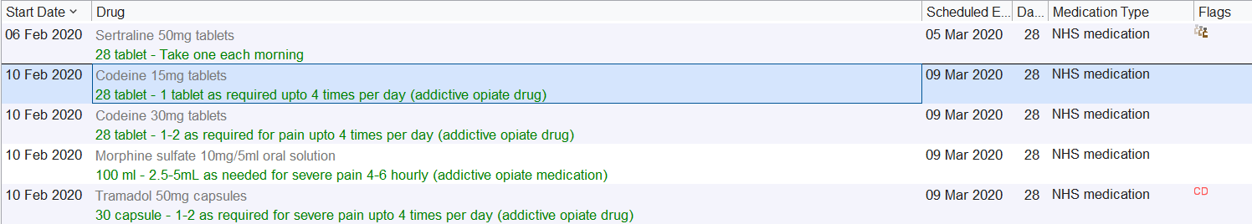
- Click on the medication being requested to highlight.

- Click on the ‘Patient requested prescription’ (circled below).

- Select the patient’s usual GP/User group.
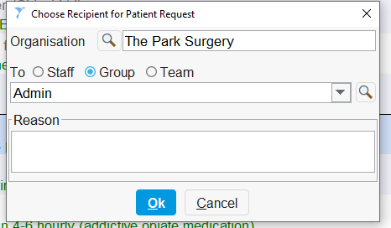

- Input relevant information (Acute medication request) into the reason box and press OK.

For both methods of ordering:
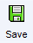
- Click Save before discarding the patient’s record.

Version Control
Date | Version Number | Change Made
29/04/2024 | v1.0 | New SOP

