SOP007: Medication requiring additional monitoring
Purpose | How to process a request for certain medications that require additional monitoring from the GP.
Scope | To be used when processing prescriptions to ensure that certain medications are highlighted to get the additional monitoring they require.
For the use of | Insert your text here

Some medications require extra attention and monitoring. See below list of these medications and the steps to take to action prescription requests for these medications.
<Please amend medication table as appropriate for your practice>
Medication requiring additional monitoring
Generic Name | Brand Name
Acenocoumarol | Sinthrome
Azathioprine | Imuran, Azapress
Ciclosporin | Neoral, Capimune, Deximune, Sandimmun, Vanquoral
Hydroxycarbamide | Hydrea, Droxia, Siklos
Lithium Carbonate | Camcolit, Priadel, Liskonum
Lithium Citrate | Priadel, Li-Liquid
Leflunomide | Arava
Mercaptopurine | Hanixol, Xaluprine
Methotrexate | Maxtrex, Metoject, Metnofill, Nordimet, Zlatel, Jylamvo
Tacrolimus | Prograf, Adoport, Advagraf, Dailiport, Evarsus, Modigraf
Warfarin
Sodium Valproate | Epilim Chrono, Epilim Chronosphere, Episenta, Epival
Valproic Acid | Belvo, Depakote, Dyzantil, Convulex, Syonell
This is not an exhaustive list.
Valproate:
Valproate (Sodium Valproate and Valproic Acid) require additional monitoring.
Extra care should be taken when prescribing especially to women of childbearing age. Prescribing must be within the terms of the PPP (Pregnancy Prevention Programme) and these medications must be prescribed in whole pack sizes.
Patients being prescribed these medications must have an ARAF (Annual Risk Assessment Form) on record.
Please refer to any other guidance that is published concerning valproate-containing medicines.
How to process requests for these medications:
POD would usually highlight these medications to the surgery via a patient request. Extra attention needs to be paid to these medications to ensure the correct monitoring takes place. <Please amend as needed in line with your processes>
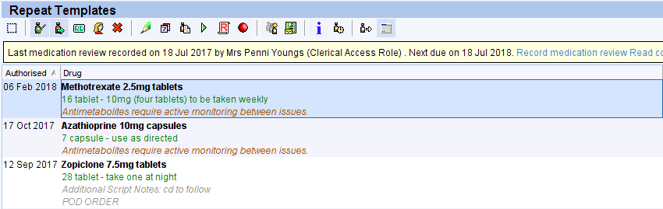
- Highlight the medication(s) that have a trigger point.

- Click on the ‘Patient requested prescription’ (circled below).

- Select the patient’s usual GP/User group, type in the reason for requesting (Medication requiring additional monitoring – Please check bloods) and click ok.

Medication requiring additional monitoring – Please check bloods

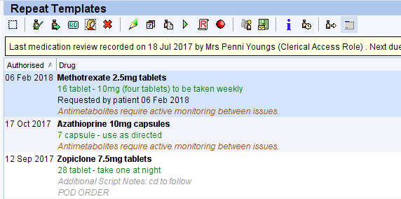
- Patient record will show that a patient request has been made.

- You can then request any other items the patient is requesting following SOP001 - Repeat Template.

- Click save before leaving the patient record.

Version Control
Date | Version Number | Change Made
8/5/2024 | v1.0 | New SOP

