SOP004: Medication Review, Individual Review and Maximum Issue Count
Purpose | How to process a prescription request if the patient’s medication review is overdue, if the Individual review date is reached or if the Maximum issues are reached on an item.
Scope | This SOP covers how to identity if a patients medication review is overdue (or if the patient has no medication review recorded) <Keep or remove this point as needed> if an item has reached its individual review date or maximum issue count and the process to follow if these are reached.
For the use of | <Enter your text here>

Medication Review
- Check if the medication review is overdue when processing the prescription request.

- Click on the repeat template tab on the clinical tree. The Medication Review information will be shown in the yellow bar at the top of the repeat template.
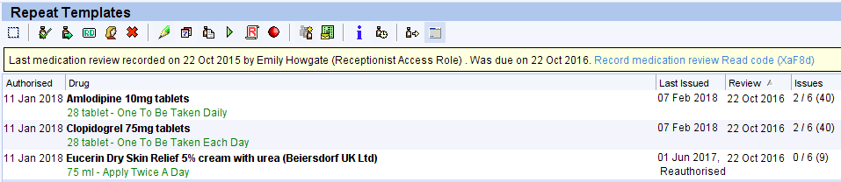
The review date here is not the Medication Review and only shows the Individual Medication Review date.

- Medication Reviews should be completed yearly. If the Medication Review is overdue the yellow bar will say ‘Was due on dd/mm/yyyy’.

- If the medication review is overdue:
POD would usually highlight this to the surgery via a patient request, Stating ‘Medication review overdue – due dd/mm/yy’. <Please insert your process here>

- If there is no medication review recorded in the yellow bar:
POD would again highlight this via a patient request, Stating ‘No medication review on record’ <Please insert your process here or remove if necessary>

Individual Review Date and Maximum Issue Count
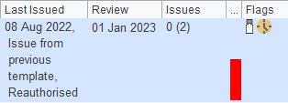
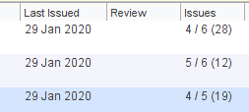
- Some prescribers will add items to repeat with a maximum issue count (Shown below in red on the left) or an individual review date (Shown below in red on the right).

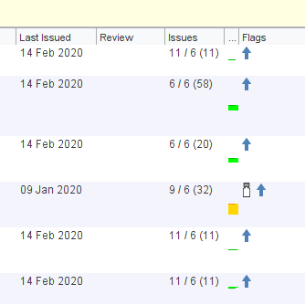
- If the maximum issue count or individual review date is reached, this will be indicatedby one of two symbols in the ‘Flags’ Column (Shown below in red).

- Alerts will also pop up highlighting maximum issues or individual review date reached if you try to issue the item. There are four pop ups you may see:

- Maximum issue count has been reached, has the extra issue been authorised?
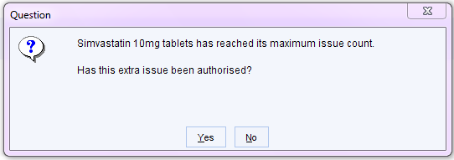
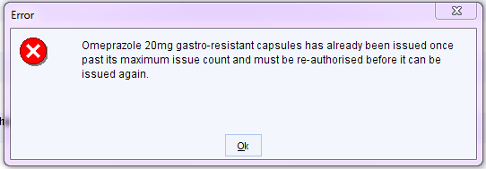
- Item has already been issued once past its maximum issue count.

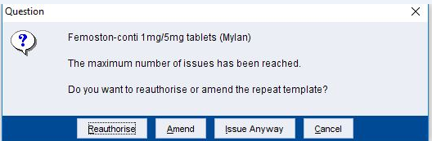
- Maximum number of issues have been reached.

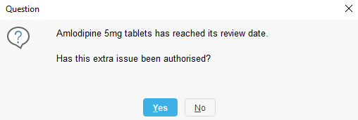
- Individual review date reached, has the extra issue been authorised?

POD would highlight the Individual review date or Maximum issue count being reached via a patient request. <Please insert your process here>
Version Control
Date | Version Number | Change Made
25/04/2024 | v1.0 | New SOP

