SOP003: Housekeeping
Purpose | A guide on how to keep a patient’s repeat template up to date.
Scope | This was created to cover the process of identifying repeat items that are not being regularly ordered and the steps to follow when these are identified.
For the use of | Enter your preferences here.

It is important repeat templates are kept up to date to accurately, reflect medications the patient is taking. This is essential for patient care and to reduce the risk of items being issued in error.
- When processing prescriptions, remember to consider items on repeat that have not been regularly ordered, for example: Item has not been issued in the last 3/6/12 months.

- Identify items that have not been requested by the patient in the last 3/6/12 months. If possible, ask the patient why they have not been ordering the item.

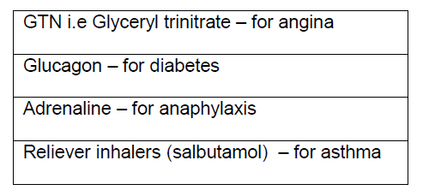
- The items listed in the box below, may be ordered infrequently. These do not need to be removed from repeat.

- If there is a valid reason as to why the item has not been ordered e.g. stock at home add this as a script note:

  - Hover over the item and right click the mouse
  - Select Amend
  - Add detail in the script notes box – always add today’s date
  - Press OK

- If the patient explains that they are no longer taking the medication. Consider if it would be appropriate to remove this from repeat.

Do you involve GP/pharmacist/ pharmacy technician when removing items from repeat to ensure this is appropriate? Please enter your process here.

- If it is appropriate to remove the item from the repeat select the ‘End the repeat template icon’
Click end the repeat template icon

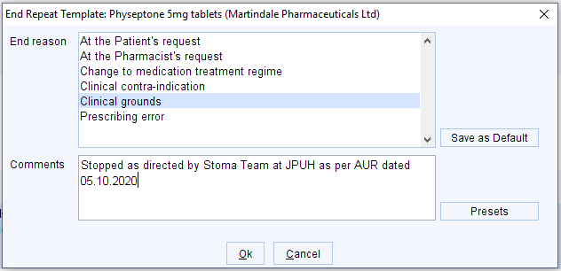
- Click the appropriate End reason from the list, then type in Comments why you are removing the medication from the repeat and input today’s date.
Patient no longer taking. Last issued 1/10/22.
19/10/2023
- Click Save 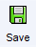 to leave the patient’s record.

Version Control
Date | Version Number | Change Made
25/04/2024 | v1.0 | New SOP

