SOP001: Repeat Template
Purpose | A guide for processing requests for medications which are on the patient’s repeat template.
Scope | This SOP is for processing repeat medications only, this excludes items which are an acute, found in the ‘Medication’ section of the clinical tree.
For the use of | Enter your text here

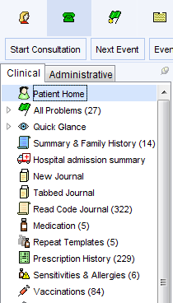

- Click on ‘Repeat Templates’ in the clinical tree.
(circled here in red)

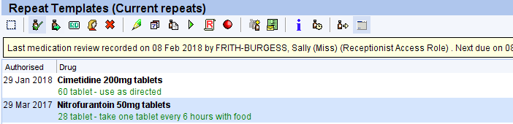
- Repeat medications will be listed here. You can click on ‘Drug’ to arrange these in alphabetical order if they are not already.

- It is important that the patient has confirmed the medication and the strength of the medication they are requesting.

If a when required (PRN) medication is requested, if possible, check with the patient that this is needed. See also SOP002.
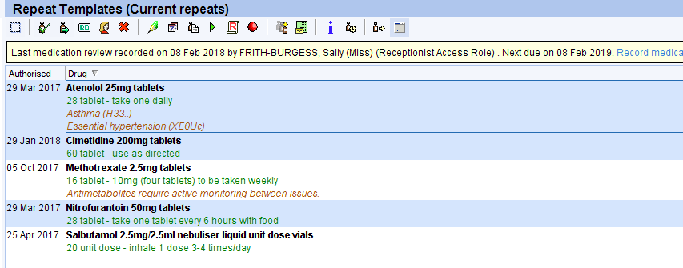
- Highlight each medication requested by the patient by holding the Ctrl & left click the mouse.

- Check if the medication review is in the date in the yellow bar at the top of the repeat template. If this is reached, <Please insert your process here>

- Check if any Individual review dates or Maximum issue counts are reached on the items being requested. If these are reached <Please insert your process here>

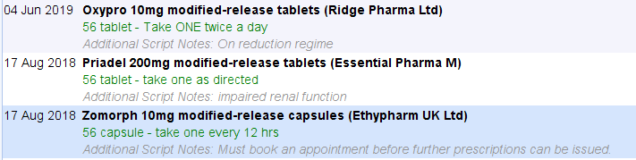
- Check for any additional script notes (in grey under the dosage), you may need to process these items in a different way. <Please insert your process here>
NB: the pharmacy and patient do not see these notes.

- If the items are ok to be issued after carrying out the relevant checks above, click on the issue icon.

- Review the items not requested by the patient – If any have not been ordered in the last 6 months please follow SOP003 – Housekeeping.
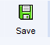
- Press F6 or click on the save icon.

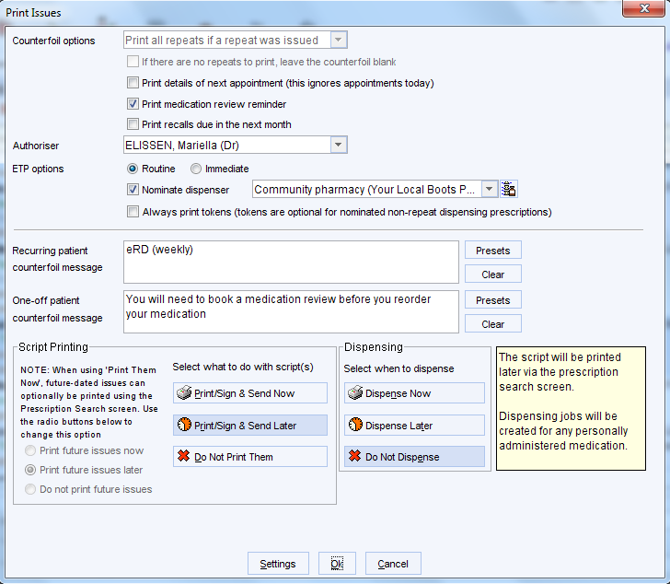
- The print issue screen will pop up
Click on pre-sets for recurring/one off messages to appear on repeat slip if needed.

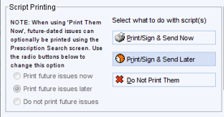
- Check the Script Printing is set correctly to Print/Sign & Send Later, this will send the electronic prescription to the GP’s inbox for digital signing.

- Press OK to send the prescription to the GP surgery signing queue.

For Dispensing Practices: <Keep/ Remove as needed>
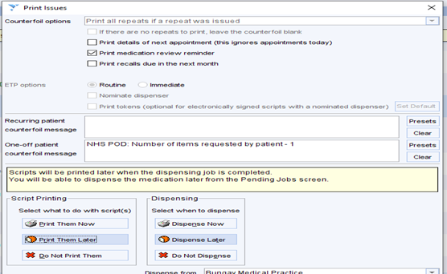
Prescription to be sent to Dispensary:

Version Control
Date | Version Number | Change Made
25/04/2024 | 1.0 | New SOP

