Step-by-step guide
for GP Practices –
EMIS / Patient Access
Setting up proxy access for authorised
Care Home staff to order medications online

Table of Contents

1 Before you start 3
2 Registering for Patient Access 4
3 EMIS – Register a proxy user 6
Adding a proxy user 7
No matching online users found 10
Register an existing online user as a proxy 13
Register a local patient as a proxy 14
4 EMIS – Manage existing online proxy users 16
5 EMIS – Recording legal basis types 17
6 EMIS – Online Service Providers 18
7 EMIS – Video Consultations 19
8 Frequently Asked Questions (FAQs) 20
9 Points of contact for additional support 22
10 Appendix 23

1 Before you start

- The GP practice should try and make sure the repeats are aligned, that interim prescriptions are being issued to bring repeats in line and quantities on repeat are appropriate for the 28-day medication cycle. This process may be assisted by the medicines optimisation team
- Have an up-to-date resident list/report from your aligned care home
- Scan and save all staff and resident authorisation forms
- Have in place your data sharing agreement signed by the care home
NOTE: If you have already set up the authorised care home staff as proxy users for ordering medication, go to Section 5 to search, and select the online user already set up in the system.
Consent must be given by the patient/resident (or their representative) before further access to the GP record is set up for care home staff.

EMIS is in direct partnership and fully integrated with Patient Access (formally known as “EMIS Access”). Patient Access is the platform that care home staff will need to register for new accounts. New registrations are then received by GP practices via their EMIS accounts. For the purpose of this document, Patient Access will be referring to the platform that care home users will be seeing and using.
The Care Home Medication Cycle
Care homes operate a 4 week (28-day) medication cycle and begin ordering medication for their service users on week 2 due to the volume of individuals being ordered for and the time needed for the GP practice to produce the prescriptions and the pharmacy to prepare the medication.
Note: When registering a patient / resident, it’s important they are registered as a ‘permanent’ resident versus a ‘temporary’ resident. Only ‘permanent’ residents will be able to have repeat medications ordered for them.

2 Registering for Patient Access

The care home staff member that is going to be registered as a proxy, first needs to be registered with Patient Access. They
Once you receive your registration letter from the Practice, use the steps below to set up your Patient Access account.
PLEASE NOTE - You must register within 2 weeks of being given your PIN number after which time it will expire. In this case you will need to contact the practice to be given another registration letter and new PIN number.
(Note: When registering, the email address field is mandatory. The details entered within the email address field will be recorded in your medical record. Only one email address can be registered per patient.)
1. Click on the Patient Access link on the practice website or go to https://www.patientaccess.com
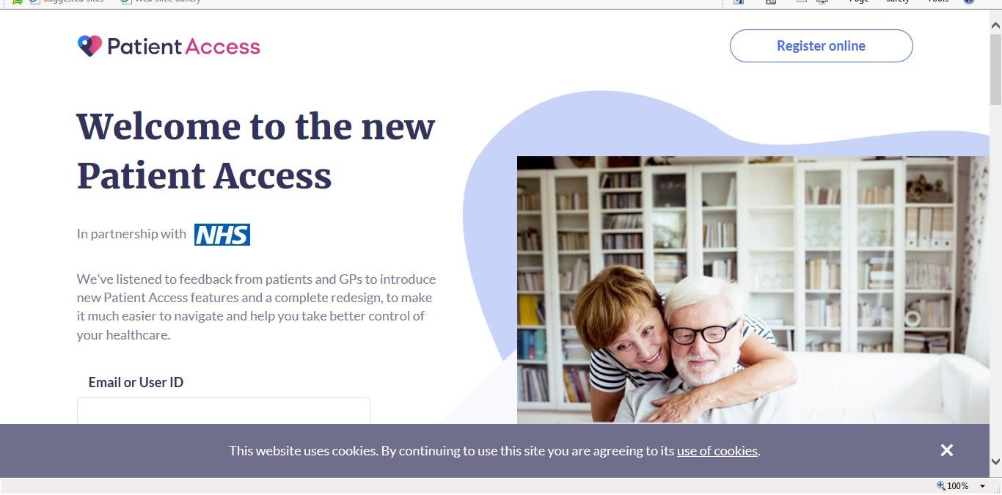
2.

Click “Register Online”

- At the next page, select “click here” for practices in Scotland.
- Complete all details, using the information from the registration letter. Complete all fields including CHI Number
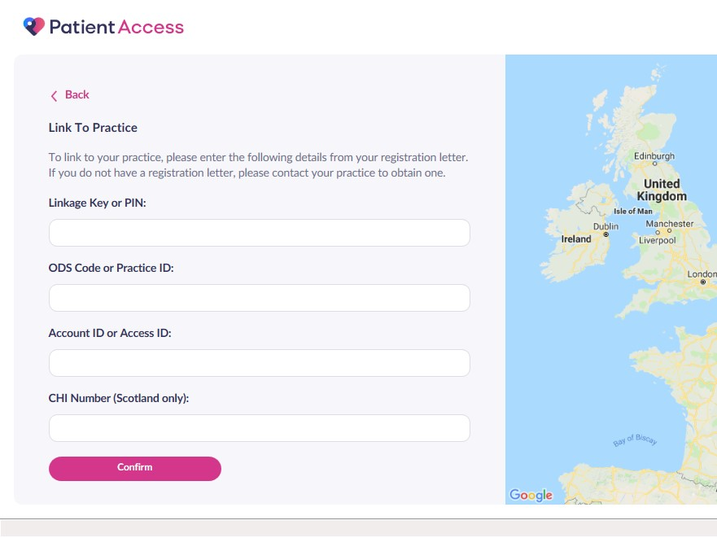

- Confirm your personal details

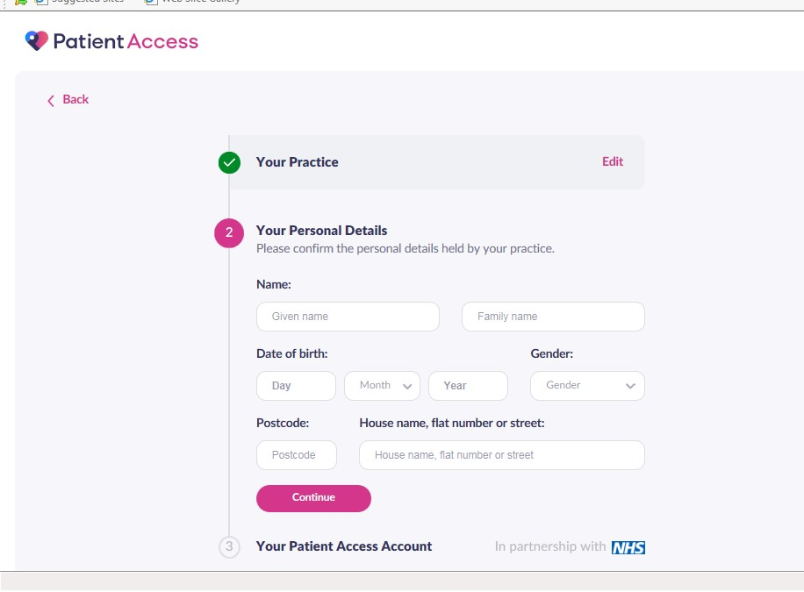

- Set up your account details and password. You will be able to log into Patient Access using either your email address or your user ID number.

3 EMIS – Register a proxy user

Key points:

- In Registration, select the patient who needs the proxy, then add the proxy user.
- The proxy has the Patient Access account. The patient does NOT need an account. The proxy is added (if not already registered as a proxy), and linked to the patient.
- The proxy will appear in Online users, plus in the Registration > Online Services section of any patient they are linked to.
- If a proxy manages various accounts, all patients they care for at your practice are displayed in the Linked patients section, at the bottom of the Online users screen.
- The proxy user does not need to be registered (as a patient) at the same practice as the patient.
- A proxy user can be linked to a patient of any age.
- There is no limit to the number of patients a proxy user can manage.

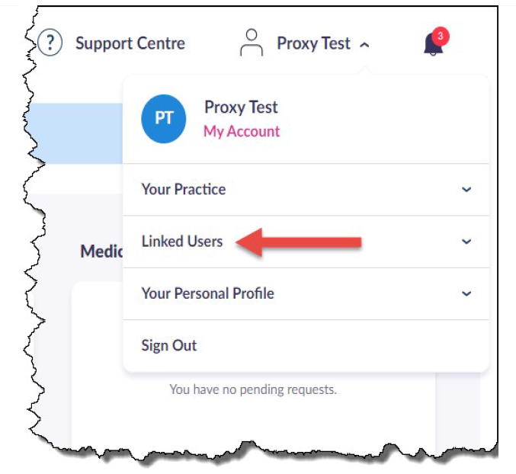

The Patient Access view for a proxy user

Adding a proxy user

1. Access Registration. Click , point to Registration, and then select Registration.
2. Select the required patient.
3. On the Registration screen, click the Online Services tab.
4. Click Add online user, then Add proxy user.
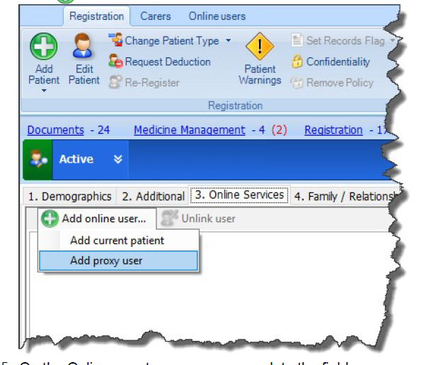

5. On the Online user trace screen, complete the fields
marked * and click Find.

When using the Online user trace screen, there are three possible outcomes. See below:

1. No matching online users found - the user is neither an online
user or registered patient.

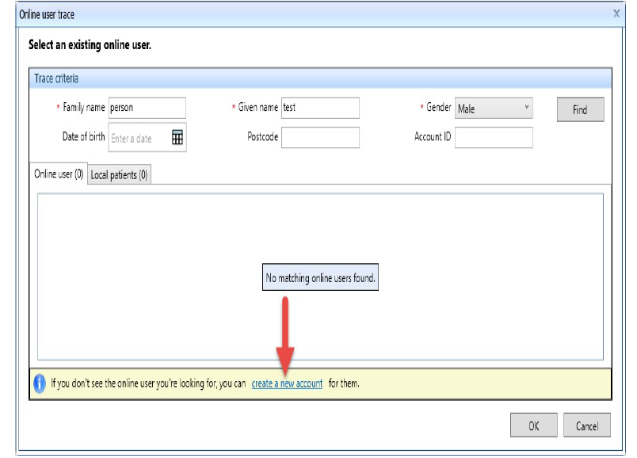
2. The user is already registered and is displayed in the Online
user tab.
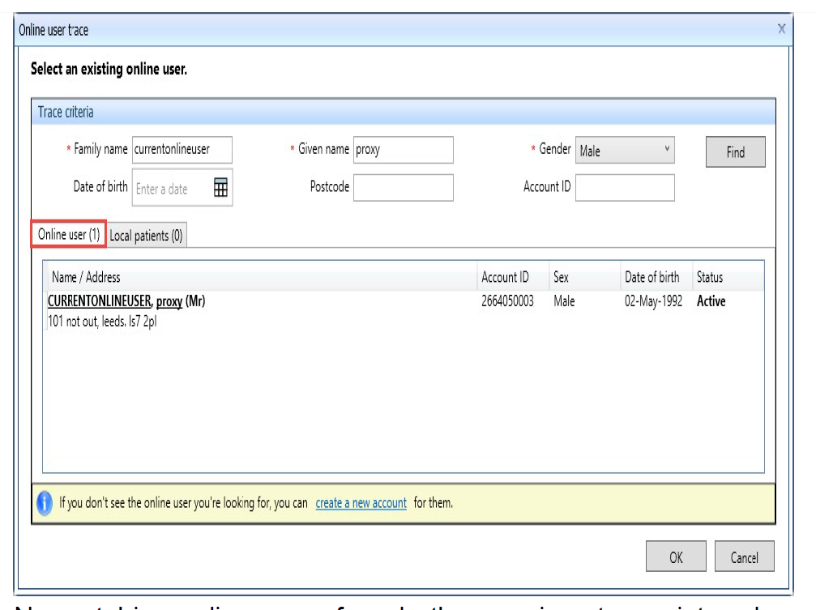
3. No matching online users found - the user is not a registered
online user, but is one of your registered patients and is
displayed in the Local patients tab.
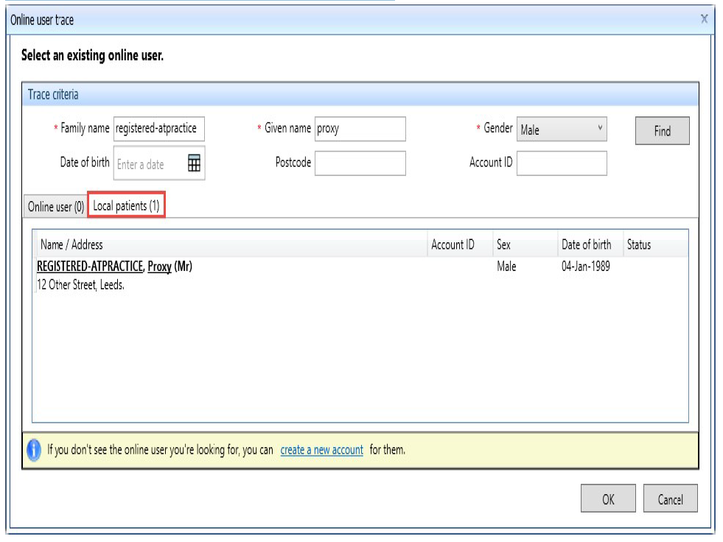

No matching online users found
Use the following steps to register a proxy user who is neither an
online user or registered (local) patient.

1. Access Registration.
Click , point to Registration, and then select Registration.
The Registration screen is displayed.

2. Select the required patient.
3. On the Registration screen, click the Online Services tab.
4. Click Add online user, then Add proxy user.
5. On the Online user trace screen, complete the fields marked
* and click Find.
6. If the proxy user is not an existing online user, and is not a
registered patient at your organisation, click create a new
account.
7. Complete the Online user screen which combines the Details,
ID Verification, Access and Legal basis pages.
Completing the Online user screen.
PAGE | SECTION | FURTHER INFORMATION
Details | Demographics | Complete the demographics  information for the proxy  user.  Note: All fields are  * mandatory.  Tip: Type in the date of birth  rather than scrolling through  the calendar, e.g. 12/04/59.
 | Contact  details | Complete the contact details  for the proxy user.  Note: The primary email  address field is * mandatory  and must be completed.
ID  Verification | Verifications | Add ID document or vouch  for the patient, with additional  options to edit or delete. The  verifications can be added,  viewed, edited or deleted at  any time in Online users >  Identity verification.
Access | Linked patient | Click and select the  relationship to the patient,  e.g. Carer.
 | Services | Select the box beside each  feature that you want the  online user to be able to use.  Appointments, repeat  prescriptions and  demographics are selected  by default but can be  removed.
 | Record access | Select the required option  and, where applicable,  configure accordingly.
Legal  basis | Legal basis | For each service you are  granting access to, the legal  basis must be confirmed by  selecting Allow access. You  can choose to reject the  service at this point, or  decide later after speaking to  the patient.  Note: If you select Decide  later, the account will be  restricted to only the services  you have allowed. If you  would like to allow further  access at a later date, find  the online user, select the  patient at the bottom of the  screen, then click Legal  basis. Select Allow access  then click OK.

8. Click Update legal basis.

If you have selected Decide later for any service, when clicking OK you will get the following message. Select Not now to proceed and complete the registration.

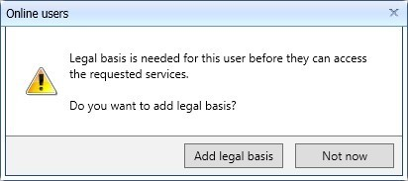
9. Click OK. The online (proxy) user is now linked to the patient.
10. Select how you would like to issue the PIN document, email, print or both. As before, the option to email the document will only be available if the user has a verified, primary email address recorded.

The online user's account is created with an account status of Active. This can be viewed under Account status in the Online users screen.

Register an existing online user as a proxy

Use the following steps to register a proxy user who is already
registered as an online user.

1. Access Registration.
Click , point to Registration, and then select Registration.
The Registration screen is displayed.
2. Select the required patient.
3. On the Registration screen, click the Online Services tab.
4. Click Add online user, then Add proxy user.
5. On the Online user trace screen, complete the fields marked
* and click Find.
6. If the user is already registered as an online user, double-click
the online user, or click once, then click Select.
7. Complete the Online user screen which combines the Access
page and Legal basis page.

Completing the Online user screen.
PAGE | SECTION | FURTHER INFORMATION
Access | Linked patient | Click and select the  relationship to the patient,  e.g. Carer.
 | Services | Select the box beside each  feature that you want the  online user to be able to use.  Appointments, repeat  prescriptions and  demographics are selected  by default but can be  removed.
 | Record access | Select the required option  and, where applicable,  configure accordingly.
Legal  basis | Legal basis | For each service you are  granting access to, the legal  basis must be confirmed by  selecting Allow access. You  can choose to reject the  service at this point, or  decide later after speaking to  the patient.  Note: If you select Decide  later, the account will be  restricted to only the services  you have allowed. If you  would like to allow further  access at a later date, find  the online user, select the  patient at the bottom of the  screen, then click Legal  basis. Select Allow access  then click OK.
8. Click Update legal basis.

If you have selected Decide later for any service, when clicking OK you will get the following message. Select Not now to proceed and complete the registration.

9. Click OK. The online (proxy) user is now linked to the patient.

Register a local patient as a proxy

Use the following steps to register a proxy user who is not a registered online user, but is one of your registered patients and appears in the Local patients tab.
1. Access Registration.
Click , point to Registration, and then select Registration.
The Registration screen is displayed.
2. Select the required patient.
3. On the Registration screen, click the Online Services tab.
4. Click Add online user, then Add proxy user.
5. On the Online user trace screen, complete the fields marked * and click Find.
6. If the user is not appearing in the Online users tab, but is registered as a patient, select the Local patients tab, double-click the patient, or click once, then click Select.
7. Complete the Online user screen which combines the Details,
ID Verification, Access and Legal basis pages.
Completing the Online user screen, as previously done here. Insert hyperlink to full chart
8. Click Update legal basis. If you have selected Decide later for any service, when
clicking OK you will get the following message. Select Not now to proceed and complete the registration.

9. Click OK. The online (proxy) user is now linked to the patient.
10. Select how you would like to issue the PIN document, email,
print or both. As before, the option to email the document will only be available if the user has a verified, primary email address recorded.

The online user's account is created with an account status of Active. This can be viewed under Account status in the Online users screen.

4 EMIS – Manage existing online proxy users

Use Online users to manage and edit online user access for existing
users.
Guide to ribbon options
SECTION | OPTION | USE TO
Find | Find online user | Select an existing online user.
Edit online  user | Edit user | Edit demographic or contact details for the  online user.
 | Close  account | Select a reason and close the account.  Tip: Use if there has been suspicious activity  on the account and the credentials may have  been compromised.
 | Identity  verification | Add, edit, delete or view verifications.
PIN  document | Print PIN | Print or re-print the PIN document.  Tip: Use if the PIN document has been lost  and never used to complete the registration  online.
 | Email PIN | Email the PIN document.  Note: The option will be greyed out if the  primary email address is not verified.
 | Print and  email PIN | Print and email the PIN document.  Note: The option will be greyed out if the  primary email address is not verified.
Account  key | Reset  account key | Reset the account key creates new sign in  details for the account in case the details have  been forgotten, and the user doesn't have the  ability to re-set online.

Edit online user access

Use the Linked patients pane at the bottom of the screen to manage the users level of access, e.g. increase access to detailed coded record. You would also use this pane to manage legal basis for proxy users.

1. Access Online users. Click , point to Registration, and then select Online users.
The Online users screen is displayed.
2. On the ribbon, click Find online user.
3. On the Online user trace screen, complete the fields marked * and click Find.
4. Double-click the online user, or click once, then click Select. Use the Linked patients pane at the bottom of the screen to manage the proxy users level of access.
5. Select the relevant patient and click Edit online user access.
6. Edit the Access page.
7. If you have increased the number of services or level of access, complete the Legal basis screen.
8. Click OK.

Unlink a proxy user

The Unlink user option in Registration is solely for proxy users, perhaps carers who only needed access for a short period of time.

You can unlink the proxy user from the patient which removes
access to that particular patient, but the proxy remains on the
system in case they are linked to other patients, or may need access
to other patients in the future.

5 EMIS – Recording legal basis types

6 EMIS – Online Service Providers

7 EMIS – Video Consultations

8 Frequently Asked Questions (FAQs)

- Do care homes have to have individual accounts for care staff?

Individual accounts must be set up for all care home staff members that are to be given proxy access for data security reasons. When you login, all the residents for that care home will be listed so they choose which resident they wish to access; this can be for more than one GP if using the same GP system (e.g. SystmOne).

- What happens if care home staff are off sick, who then requests the medication for their assigned patients?

It is the care home's responsibility to have a minimum of two members of staff who can request medication and also to inform the surgery of any staff leavers or joiners.

- What patient information do care home staff have access to, just repeat template, or other clinical info?

It depends what access is given by the practice as they remain the data controller. With standard proxy access, the care home can access demographic information and medication that’s is available for order. Any further access would need to be discussed with the practice and care homes locally.

- Do Care Homes with residents registered in more than one surgery, do they need more than one account? One for each practice?

No, they can have one account if all practices are on the same GP system. The GP practices will have to make a local agreement to decide who maintains the care home staff member accounts.

- With regards to verbal consent - do you have to obtain signature or write on the form "verbal consent obtained"?
Best practice advises that you must record that you have informed all the residents of the changes in process, the template can be adapted and used for this, to be discussed, agreed and recorded locally at the start of the project how this is to be addressed.
- If there were any medications not on repeat or on acute, but started by the hospital, how is that dealt with by the care home?

By a secure email to the GP practice or by phone if urgent.

- Have the number of missing items gone down under proxy ordering?

Yes, considerably.

- There is no audit trail for whether an acute medicine (outside of the normal cycle) request has been accepted or not. Is there any solution for this?

The request for an acute medication is made via a note and these are recorded on the GP system but there is no way for the practice to confirm the note has been actioned. Current process would not change to follow up any urgent issues to ring the surgery/pharmacy where needed or send an email if not urgent.

- If a care home staff member leaves the care home, what should happen?

The care home manager should notify the GP surgery immediately when and/or prior to a care home staff member leaving the care home. The GP surgery will remove the care home staff member’s proxy access for the current care home, as well as their ability to access online services for any other access they may have.

- A new care home resident has just been changed from one GP practice to our practice, but I can’t see the record on SystmOne? Why is that?

Sometimes, it takes a few days for the record to fully transfer over. You may be able to see items within the patient’s / resident’s record, but you can’t change them. Ensure that there is communication between the GP practice and the care home, and all pertinent notes are documented accordingly. If this does occur for longer than one week, please contact the SystmOne helpdesk at 01132 050095.

- When I search for a list of residents by the care home’s address, only some residents show and not others? How can I make them all show at the same time?

The reason that some residents within a care home show and not all residents is most likely because some residents have their care home address documents slightly different. To alleviate this problem, you will need to check the care home address for every resident and make sure it is exactly the same for all.

- Why are some proxy accounts restricted or revoked for patients in EMIS?
When a patient reaches the age of 11, any proxy accounts attached will be restricted. This is so a clinician can assess whether or not the patient is competent to manage their own account. The proxy user will be notified of this by email three months prior to the patient’s birthday. Additionally, when a patient reaches the age of 16, any proxy accounts attached to the patient will be no longer linked (as 16 is the age when patients are deemed competent to manage their own healthcare). The proxy user will be notified of this by email three months prior to the patient’s birthday. The proxy user needs to be added again to the patient’s account if they still require access.

9 Points of contact for additional support

The Norfolk and Waveney CCG Digital Care Homes team is able to provide comprehensive, responsive and effective support for your digital needs. We pride ourselves in working a collaborative manner with all Care Homes, GP surgeries, Pharmacies and other NHS Trusts in the Norfolk and Waveney area to provide you with a high-quality, streamlined service.
Below are the contact details for the team, to include each team member:

Marie Baron Claire Gilbert
Digital Project Manager – Care Homes Care Consultant – Care Homes
Marie.Baron@nhs.net Claire.Gilbert10@nhs.net
Mobile: 07738 151267 Mobile: 07584 047996

Jackie Mansueto Sharon Laws
Digital Change Facilitator Digital Change Facilitator
Jackie.Mansueto@nhs.net Sharon.Laws2@nhs.net
Mobile: 07974 628311 Mobile: 07813 395342

Chat with us on Teams!
Shared Digital Email: nwccg.digital4carehomes@nhs.net

10 Appendix

APPENDIX 1 – Resident Leaflet
APPENDIX 2 – Resident Consent Form v1
APPENDIX 3 – Staff Proxy Access Request Form v1
APPENDIX 4 – Staff Proxy Access Information Leaflet v1
APPENDIX 5 – Proxy Access for Medication Good Practice Guide v1

