Allowing Care Home staff to take your observations and send them to your GP

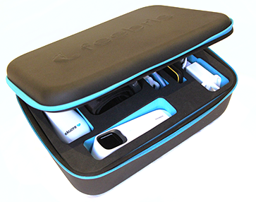
Your Care Home has been supplied with a Feebris Remote Observation Kit for staff to take your observations and send them directly to your GP.

The information that the Care Home will provide to your GP is:
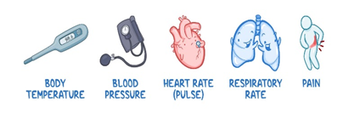
Blood pressure, Oxygen Levels, Temperature, Respiration Rate and a short questionnaire about your health.
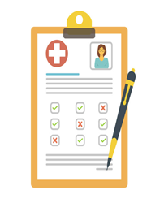
The Care Home Staff will not take these observations using the equipment unless you have signed a form showing that you agree to this.
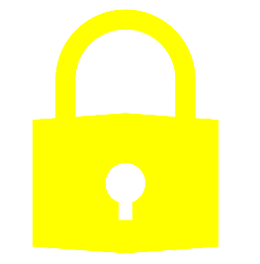
The Care Home staff will sign a form to agree to keep your information safe, secure, and confidential.
You do not have to agree and saying no will not affect your ability to access medical services.
There will be a log of every time your observations are taken and who accesses them.
You can change your mind at any time.

