How to update your NHS account information

- Open the NHSmail 2 Portal - Home
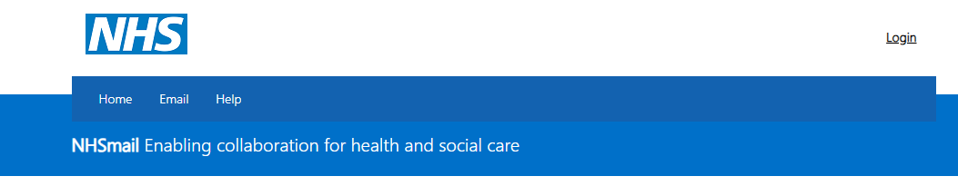
- Select ‘login’

- Enter your email address and password and select ‘sign in’ button.
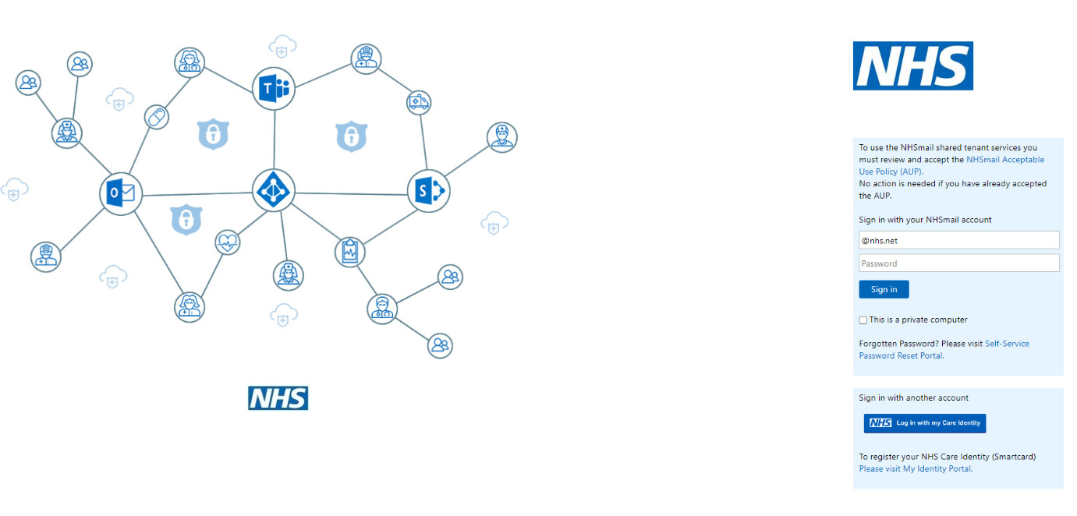

- Select the ‘profile’ option from the menu.

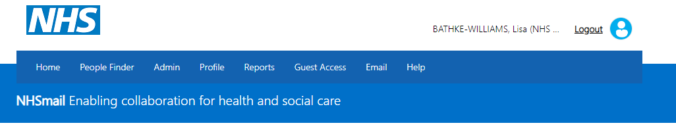

- Your ‘My Profile’ page will load, and you will be able to update your profile information, security questions and password.

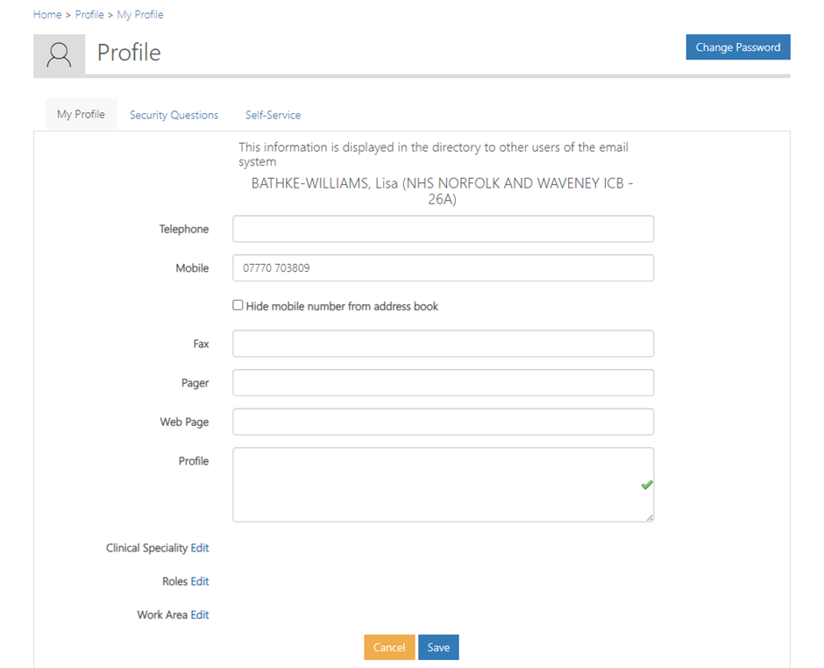

- Once you have made your changes, click save.
