How to password reset your NHSmail Account
- Open a web browser and go to NHSmail Portal - https://portal.nhs.net and click on login at the top right corner of the screen (See red circle below.)
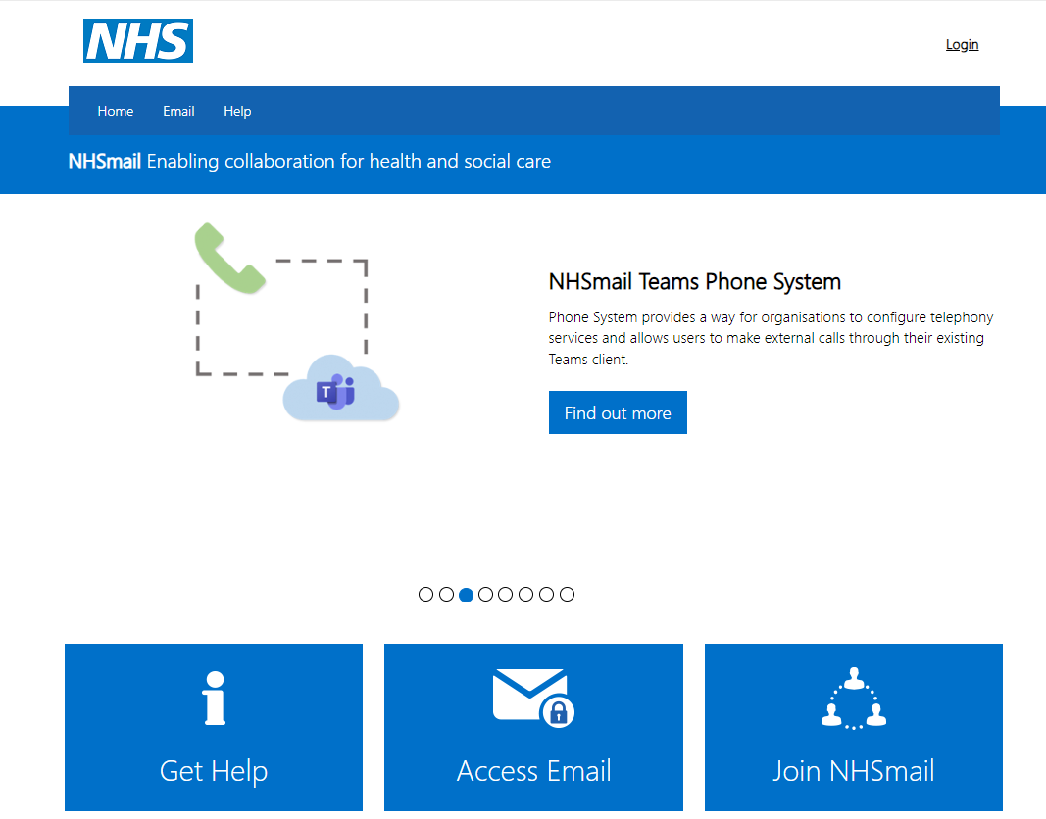

- Click on the Self-Service Password Reset Portal (See red circle below.)
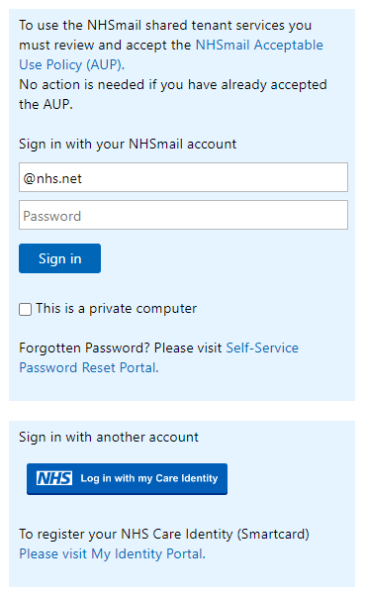

- On the get back into your account page, enter your @nhs.net email address in the Email or Username.
- On the Captcha box, enter the characters shown on the screen (they are not case sensitive so can be in upper or low case.)
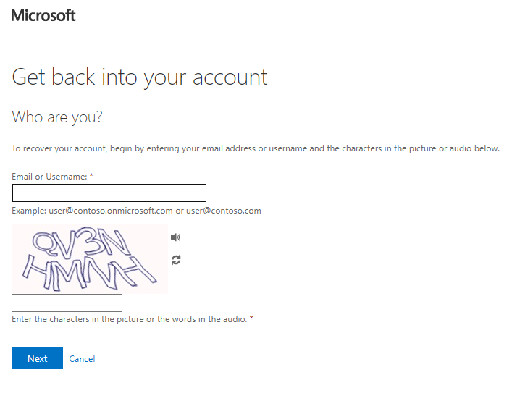

- Select a verification method from the list below:
Mobile phone:
- Select send a text to my mobile phone number on the left-hand menu of the screen.
- Enter the full mobile number.
- Check your mobile phone for the incoming text message from Microsoft and note the verification code.
- Enter the verification code on the screen and select next.
- If no message is received or the code expires select, try again, and await a new code.
- On the choose a new password page, enter a new password, and confirm your password and select finish.
- Once you receive a password reset confirmation notification on your screen, close the tab.
- Go back to the https://portal.nhs.net and login with your new password.
- Using your Authenticator App:
- Select Enter a code from my authenticator app on the left menu on the screen.
- Go to your mobile phone and open the Authenticator App.
- Look for your @nhs.net account and tap on top of it.
- Take note of the One-time password code.
- Note: A new One-time password code is generated every 30 seconds.
- Go back to your desktop or laptop and enter the One-Time password code on the screen, then click on Next.
- On the Choose a new password page, enter a new password, confirm your password and then select Finish.
- Once you receive a password reset confirmation notification on the screen, close the browser window/tab.
- Go back to https://portal.nhs.net and login using the new password.

For your password to be valid it must meet the following criteria:
- Minimum length – 10 characters without requiring a mix of character types.
- Should not contain the ‘£’ character.
- Not matching previous 4 passwords
- Not detected as a common password, for example Password123, Winter2018.
- Not detected as a breached password (a password used for an account that has previously been compromised). Breached passwords will be sourced from an internet-based breach database.
- If you receive an error when attempting to change your password, check that it meets the requirements listed above and try again.

Additional considerations
If you access NHSmail using a number of different methods (e.g. Outlook, mobile phone, tablet), you must update your new password on each application and device as soon as possible to prevent your account from becoming locked.

