How to login to your inbox and review your email

- Open the NHSmail 2 Portal - Home
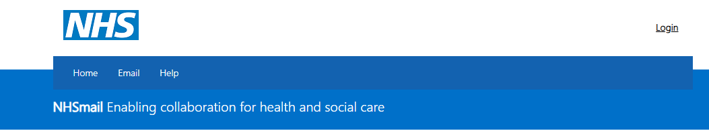
- Select ‘login’

- Enter your email address and password and select ‘sign in’ button.
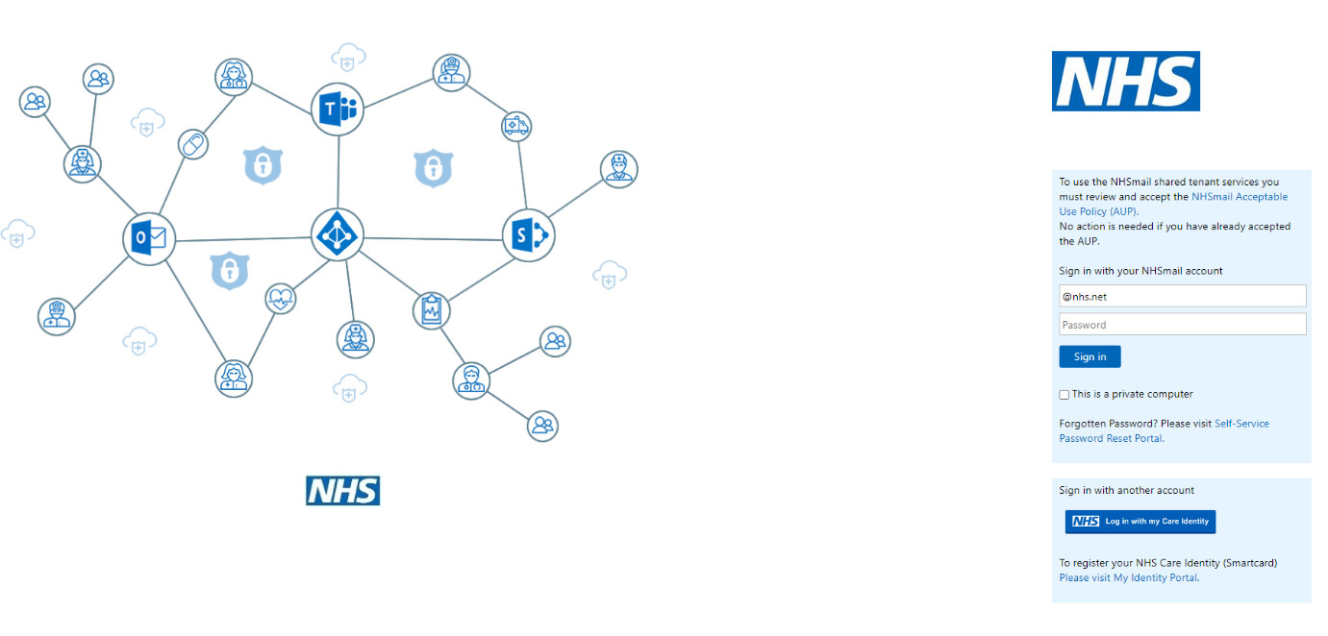

- Select the ‘email’ option from the menu.
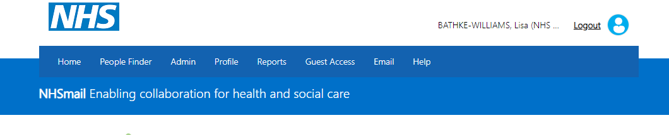

- A new tab will open with your NHSmail email box.
