How to complete the NHSmail social care provider registration portal
- Visit the NHSmail social care registration portal at NHSmail 2 Portal - Home
- This will take you to the first page, entitled ‘Care Provider Pre-Requisite Questionnaire’.
- You will require the following information to complete the ‘Care Provider Pre-Requisite Questionnaire’ – organisation postcode, care provider name, and optionally your registered managers email address. If you do not have your registered managers email address, you will require access to the CQC registered email address.
- Do you already have NHSmail account? Select No.
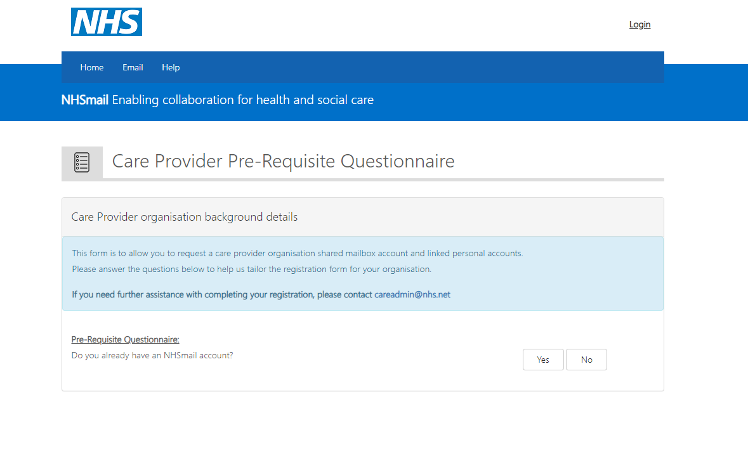

- To set up NHSmail it is required you have a Data Security Protection Toolkit at approaching standards or higher for the current year. If this is not the case or you are unsure, please see ‘How to check your DSPT guide.’
- Select yes if you have completed your DSPT.
- Select yes or no depending on if you your CQC contact ID (Registered Managers ID.)
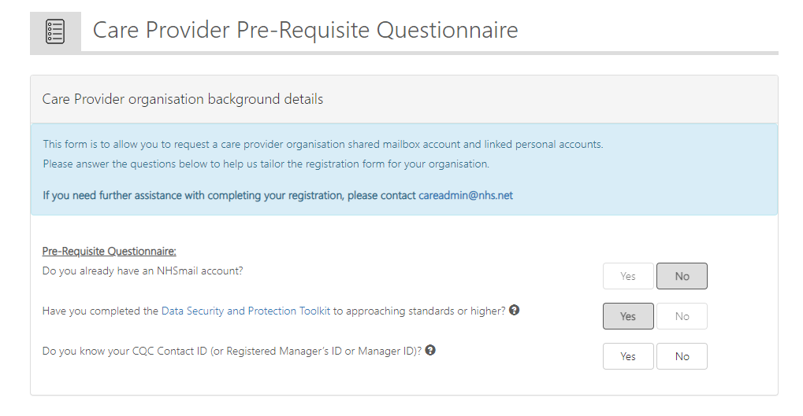

If you don’t know your CQC contact ID (or Registered Manager’s ID or Manager ID)
- If you select No to do you know your CQC contact ID (or Registered Manger’s ID or Manager ID) you will be asked if you have access to the CQC registered email address that is associated with your care home.
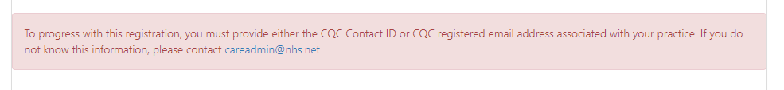
- If you select NO, you will not be able to progress with the portal and the below box will appear.

- If you select yes, you will be asked if you have already received an email containing a One-Time Passcode within the past 3 weeks. Select Yes if you have and no if you haven’t. Either option will load you to the care provider organisation background details section.
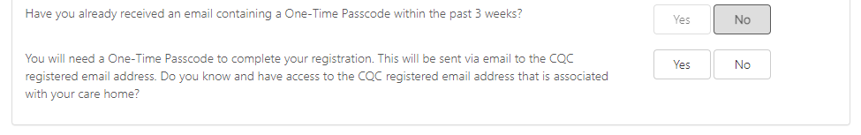

- Please enter your locations postcode. Your location details will appear automatically in the organisation name and organisation ODS code boxes. Please enter your Registered Manager’s email address.Select next.
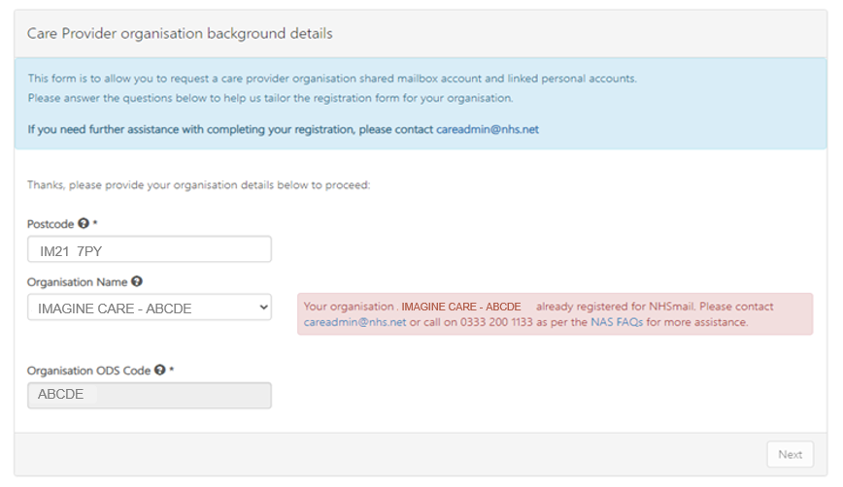
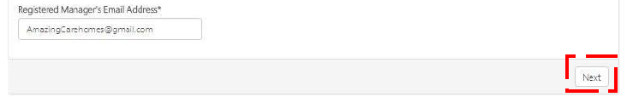
Imaginecare@imaginecare.com

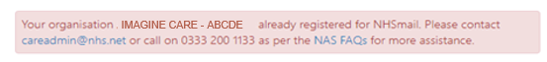
- If you have had NHSmail in the past a red box will appear and indicate you need to get support through the helpdesk. You will not be able to use the portal to set up NHSmail. See ‘Contacting the helpdesk guides.’

- Please enter the social care provider ODS code and CQC location ID. Then enter your one-time passcode, if you have requested this in the pre-requisite questionnaire or your CQC contact ID. (You will be able to find your contact ID within your CQC registration information. This is known as the registered managers ID.) Select next,
- If your details are correct/authenticated, you will be able to proceed.
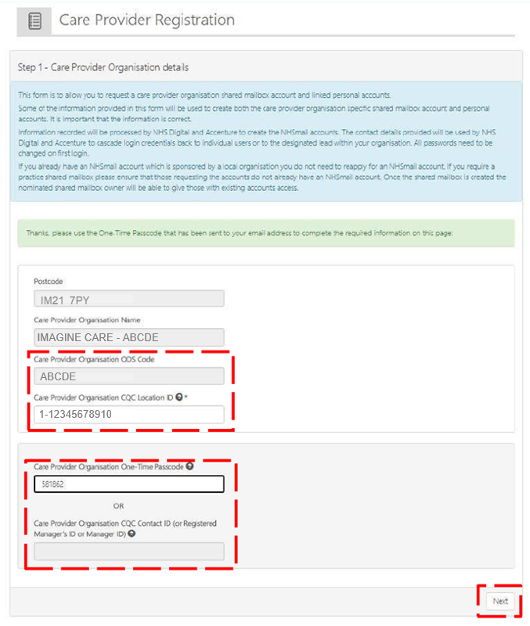

1234

- You will need to add your town details and members you wish to register for your shared mailbox and to have NHSmail.
- Enter your care location postcode and town name (town name is limited to 10 characters. Any names more than 10 characters will be abbreviated.)

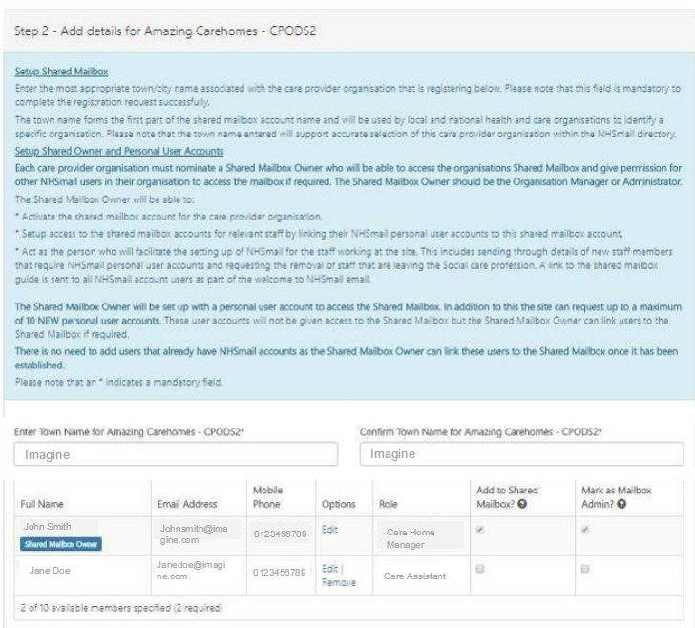

- Enter the names of the staff member who will require personal NHSmail email accounts. You need at least two staff members and a maximum of ten staff.
- The first staff member entered will be the shared mailbox owner.
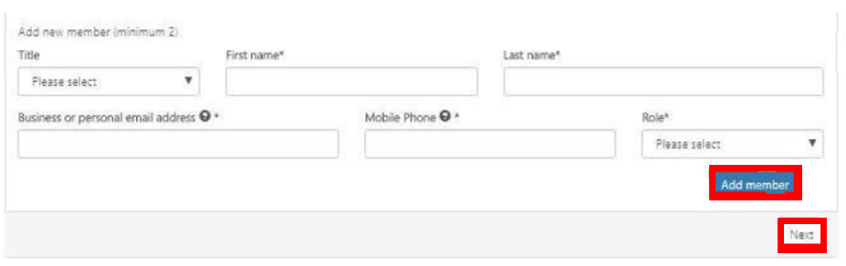

- As you add more staff you can give administration rights to select staff, by ticking the box. Mark as mailbox admin (See red circle.)
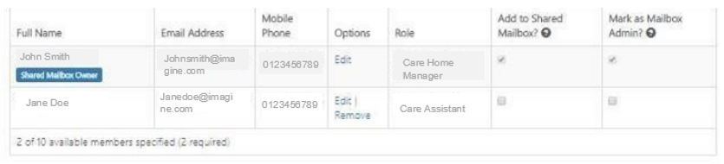

- The shared mailbox owner can be a manager or an administrator, depending on your preference. We would suggest having more than one owner. The mailbox owner will be responsible for managing the shared mailbox permissions/access.
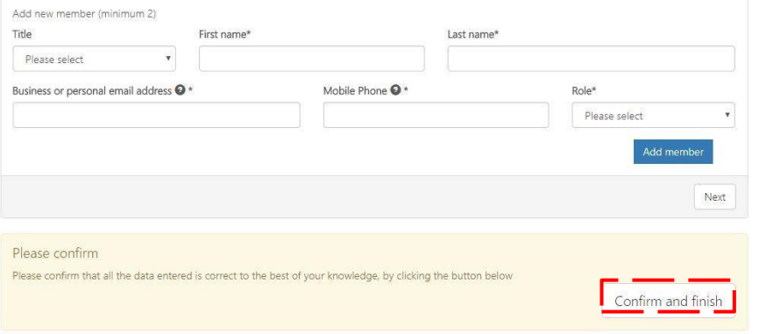
- If you have any staff who already have NHSmail personal accounts that end in @nhs.net do not add them to this form as it will make another duplicate account. You will be able to move them over once the mailbox has been set up.

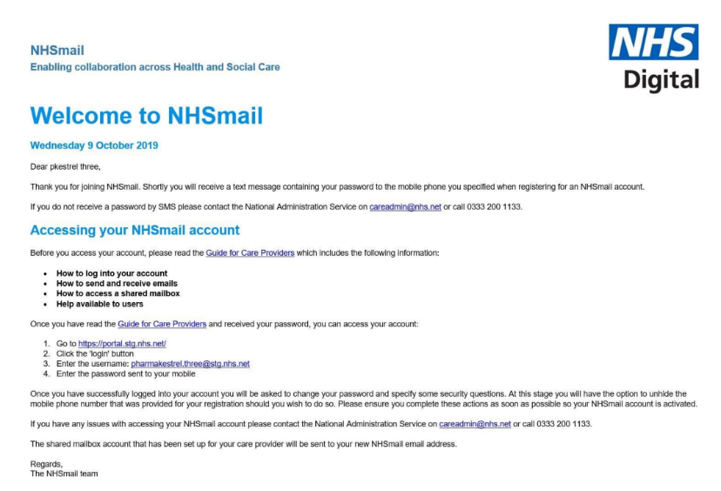
- Once you have filled in the form and added all your staff select the confirm and finish button (see red square.)

- Once your registration request has been submitted and or email will be sent to the email addresses supplied advising of usernames. The email will also have instructions on how to activate your new NHSmail accounts. It will also provide information on how to use it.

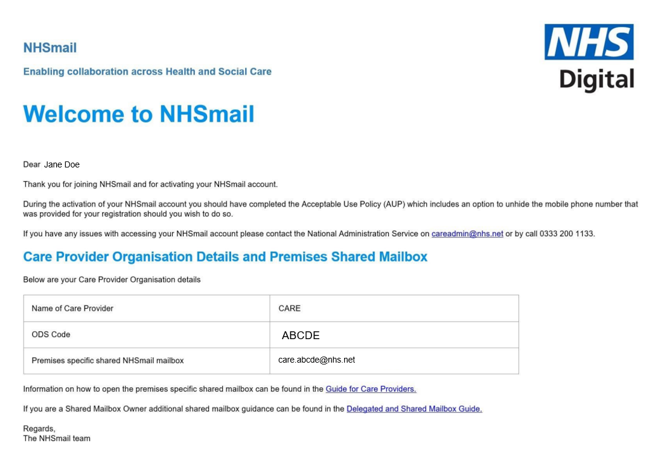

- The temporary passwords for these accounts will be sent by text to the individual staff mobile phone numbers provided when you registered them on the portal.
- Once staff have logged into their NHSmail accounts for the first time, they will see an email confirming the email address of the shared mailbox and how to access this.

