How to check if your social care site has registered for NHSmail in the past
- Visit the NHSmail social care registration portal at NHSmail 2 Portal - Home
- This will take you to the first page, entitled ‘Care Provider Pre-Requisite Questionnaire’.
- Do you already have NHSmail account? Select No.
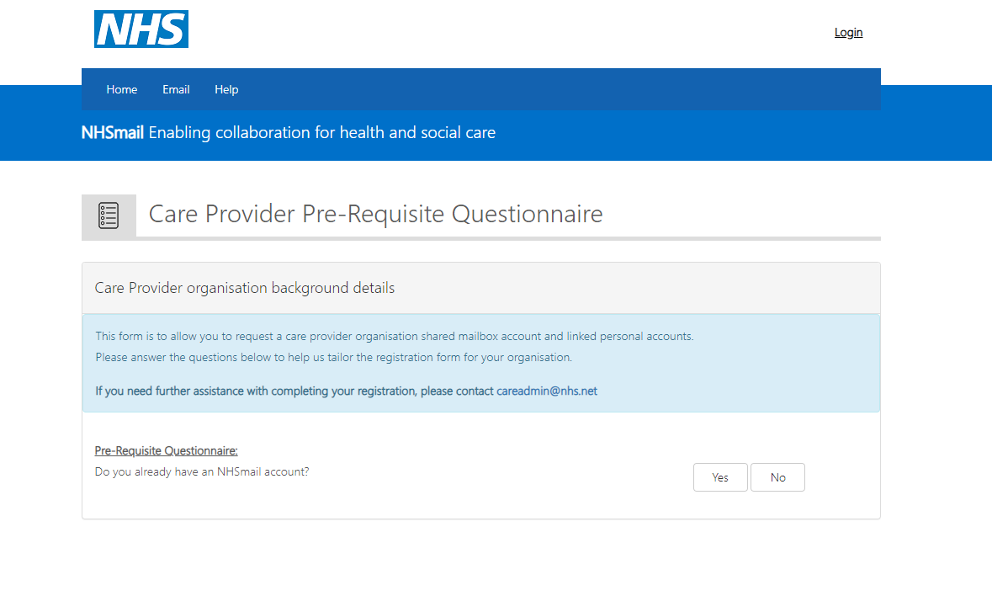

- To set up NHSmail it is required you have a Data Security Protection Toolkit at approaching standards or higher for the current year. If this is not the case or you are unsure, please see ‘How to check your DSPT guide.’
- Select yes if you have completed your DSPT.
- Select yes to do you know your CQC contact ID.
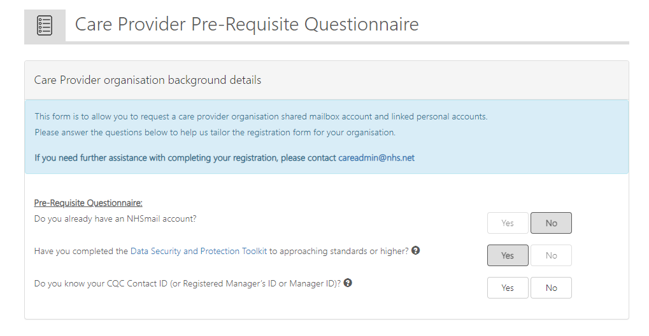

- Please enter your locations postcode. Your location details will appear automatically in the organisation name and organisation ODS code boxes.

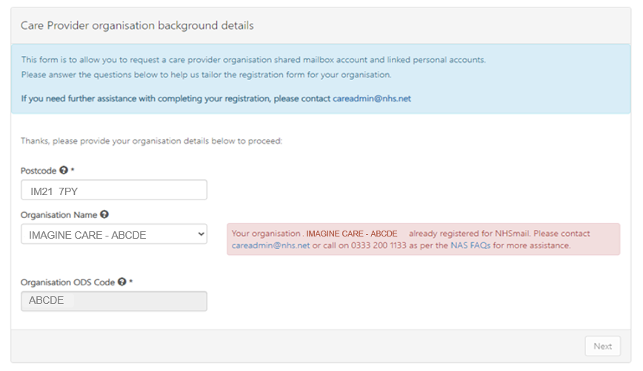

- If you have had NHSmail in the past a red box will appear and indicate you need to get support through the helpdesk.
- If you haven’t you will be able to use the social care provider registation portal to set up NHSmail for you site. Please see ‘How to complete the NHSmail social care provider registration portal.

