**How to check if you have access to your shared mailbox V1**

1. Please log in to your NHSmail account via the portal - [Sign In (nhs.net)](https://fs.nhs.net/adfs/ls/?wtrealm=urn%3aPROD.Portal.NHSMail&wctx=WsFedOwinState%3dTuwKlzTWRo7LziYaujdsSLi4kozx7jU6Mog2sLmk25Ba9DW3NoDOozrDRqVg8IFXJtpqUHCePEFEsIq8MAiqJCgXM5KYNy02foU5NCBHENkQ6BH-vtLOSsZ_8DLDJcK9imR7QIRz1vDcG6lZPz_YAA&wa=wsignin1.0)
2. Select email once logged in.

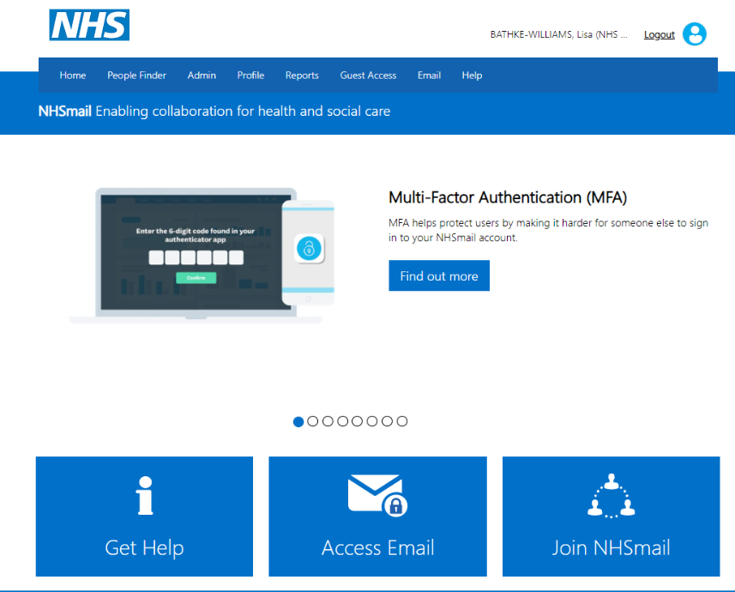

BARRY…

1. Look into the top right corner and click on the icon which will have your initials.



BARRY …



1. Click open another mailbox.
2. Type care.ADDYOURODSCODEHERE@nhs.net into the search bar. Once you find your mailbox select open. If it opens, you have access and if it doesn’t you don’t.

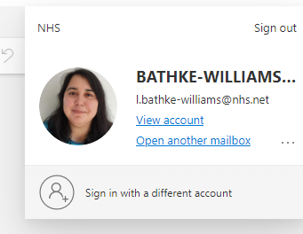

**BARRY…**

Adam.barry@nhs.net

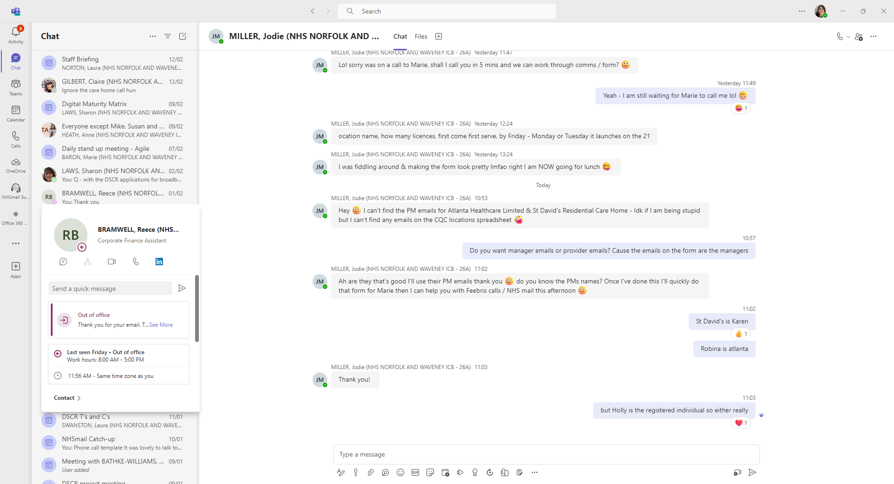

1. If you don’t send an email to [careadmin@nhs.net](mailto:careadmin@nhs.net) asking for them to link your personal NHSmail account to your shared mailbox. If someone else at the home has access and is an owner, ask them to add you to the shared mailbox. See how to add and remove NHSmail accounts from the shared mailbox guide.

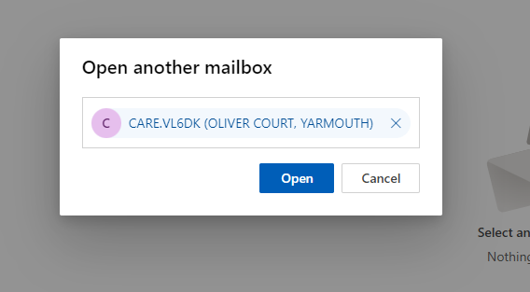

ADDYOURODSCODEHERE@nhs.net