How to add your NHSmail email to Outlook

To configure Outlook with your NHSmail account please follow these steps.

- Open Outlook App
- Click ‘File’ on the top left of the window.
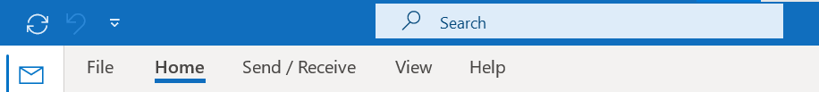

- Click the ‘Account Settings’ button, and select ‘Account Settings’

- Select your Exchange account and click the ‘add Account’ button.
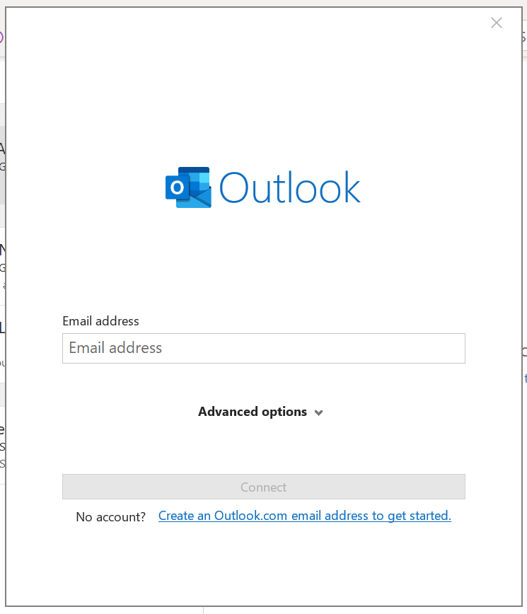

- Enter the shared mailbox email address and Click ‘Connect’ at the bottom of the window.

- Select the ‘outlook.com’ tab.

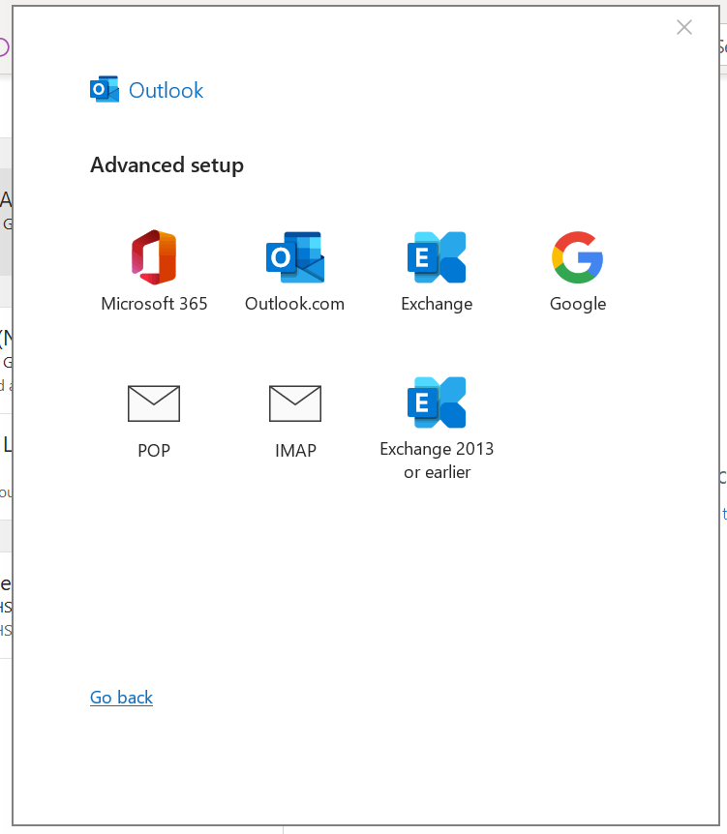

- Click ‘OK and ‘Close’

- Close your outlook and reopen it. Your additional mailbox should be added.
