How to add & remove NHSmail accounts to the shared mailbox if you are an owner of the shared mailbox

If you’re an owner of your shared mailbox and the staff member has an individual NHSmail account not linked to the shared mailbox

- Log onto the NHSmail Portal - NHSmail 2 Portal - Home
- Once logged in find profile and select from the drop-down menu – my shared mailboxes (See red circles.)

- Select Mailbox Type and in the drop-down menu select ‘shared.’

- Your shared mailbox linked to your NHSmail account should appear. Select the shared mailbox. If not, use the email section and search using the magnifying glass.
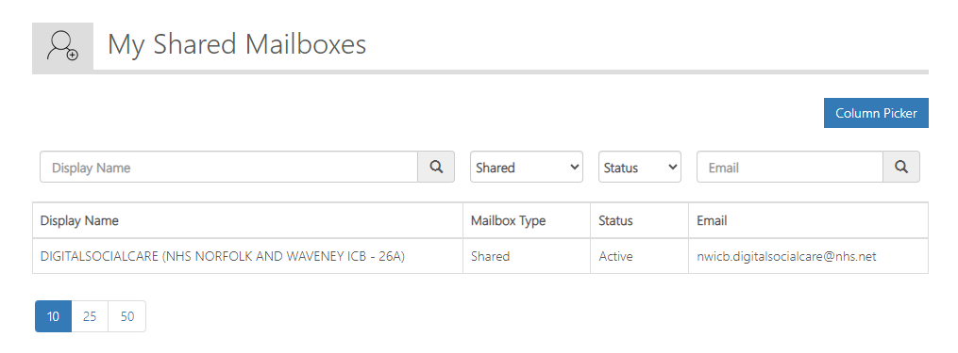

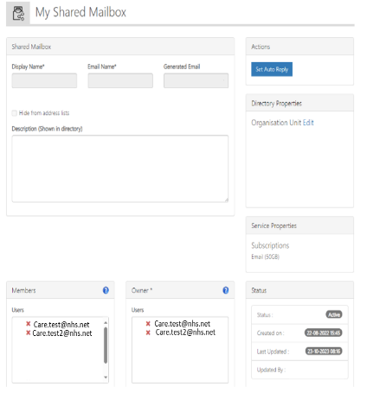
Care Home
Carehome@nhs.net
Care Home

- Your shared mailbox details will load.

- At the bottom it will list members and owners of the shared mailbox.
- If you wish to remove someone select the red X (See red circle) next to their name and remove. Make sure you select the update button at the bottom to save your changes.
- To add an email, select the add button depending on if you want to make them an owner or a member. If for both, you will need to follow these instructions twice in each section (Orange circle.)
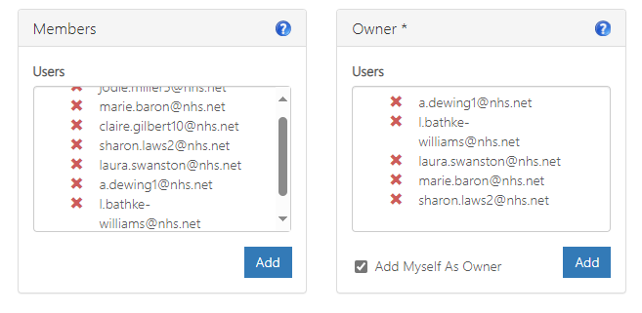
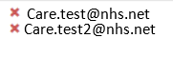

- In email search bar, type out the staff members NHSmail email address and search using the magnifying glass. Check the details and select the staff member by ticking the box next to their display name. Press the select blue button at the bottom of the screen.
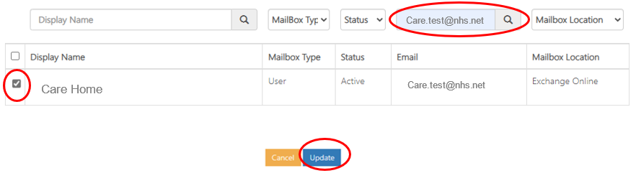

- There email details should appear in the members or owner box depending on which you added them to. At the bottom of the page select the update button to save changes.

