GP Practice –
S1 User Guide
Setting up proxy access for authorised
Care Home staff to order medications online

Table of Contents

1 Before you start 3
2 Setting up a new proxy account 4
3 Linking a staff member to a patient's / resident’s profile (new user) 10
4 Linking a staff member to a patient's / resident’s profile (existing user) at the same GP practice 15
5 Changing a user’s access rights for GP practice staff 19
6 Removing and editing online user access 21
7 Resetting an Online User Account 23
8 Frequently Asked Questions (FAQs) 25
8 Points of contact for additional support 27
9 Appendix 28

Before you start

- Have an up-to-date resident list/report from your aligned care home
- Scan and save all staff and resident authorisation forms
- Have in place your data sharing agreement signed by the care home
- If you have already set up the authorised care home staff as proxy users for ordering medication, go to Section 4 to search, and select the online user already set up in the system.
IMPORTANT
Consent must be given by the patient/resident (or their representative) before further access to the GP record is set up for care home staff.
When setting up proxy access, you must set it up for care home staff members only. You should never give out a patient’s / resident’s username and password to care home staff as it’s considered a poor Information Governance practice and there is no audit trail if multiple care home staff login as the resident.

The proxy access can also be used to permit access to patient summary care records (SCR), to book appointments and to send GP practices messages. The options available to the administrator account are controlled by the GP practice and depend on individual consent from patients.
Electronic Prescription Service (EPS)
GP practices need to be using EPS and have activated the SystmOnline ordering process to be involved in care home proxy medication ordering. There is no change for the prescribers, the prescription generated will be sent to the usual pharmacy and signed as normal. The requests for prescriptions will come through to the surgery as a task, in the same manner that an individual patient’s online order request currently presents on the system.
The Care Home Medication Cycle
Care homes operate a 4-week (28-day) medication cycle and begin ordering medication for their service users on week 2 due to the volume of individuals being ordered for and the time needed for the GP practice to produce the prescriptions and the pharmacy to prepare the medication.
Helpful video tutorial:
This helpful video was created by Debby Faries, Care Home Advice Pharmacy Technician, in the East Midlands. In addition to great tips, it provides a comprehensive visual guide for how to set up care home staff with proxy access.
https://www.youtube.com/watch?v=59JybO3gTJ0

2 Setting up a new proxy account

STEP 1
In order for care home staff to order medications for patients/residents, you are going to first set up care home staff members as a SystmOne user by creating a New Online User Account. To do this, from the Main Menu select: Patient > Patient Maintenance > New Online User Account.

STEP 2
Enter the care home staff member’s name and Date of Birth to see if they are registered on SystmOne and on the Spine. In this guide, “Harry Potter” will be the care home staff member and “John Lewis” will the patient/resident.
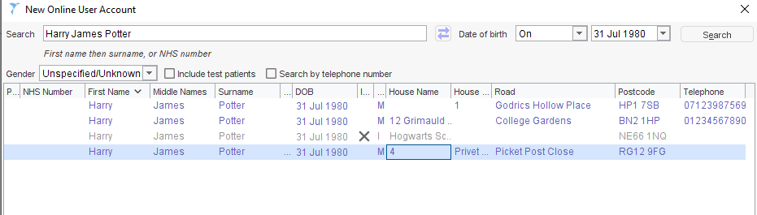
If any care home staff are found that match the search criteria, they are displayed. SystmOne uses the following colour coding:
Black – Spine care home staff record
Blue – Currently registered on SystmOne
Grey – Care home staff not currently registered on SystmOne but has been in the past

STEP 3
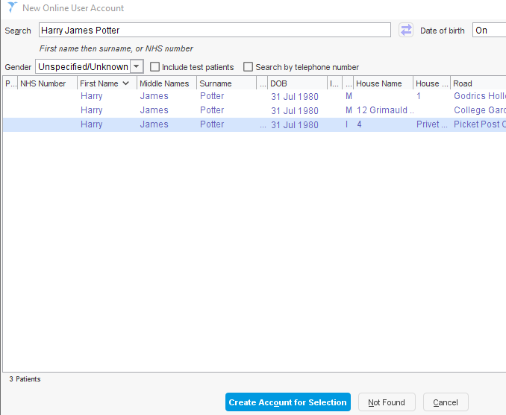
There are three possible options that may be returned:
1.You can’t find their name. Select Not Found
2. You find the person’s name, but the record includes an NHS number. You need to create a new user and without an NHS number, select Not Found
3. You find the name, without an NHS number. It’s possible that the member of care home staff has been set up as a proxy in another TPP practice.

STEP 3 (continued)
This would be applicable for a care home staff member in a care home which has residents that are registered at more than one GP practice. Double click on the care home staff member’s name to see if the account is linked to the staff and their current care home. If they are not linked, then the staff member needs to be registered again for the current care home. Select their name without the NHS number to continue a new user registration.
If the care home staff member is linked, follow instructions in Section 3.
Note: If you select Create Account for Selection above, and you change any of the details on the New Online User Account dialog, it will amend the details held on the SystmOne database for that care home staff and may update Spine.
If there is both a black Spine and a blue SystmOne match that have the correct details, choose the blue non-Spine account.

STEP 4
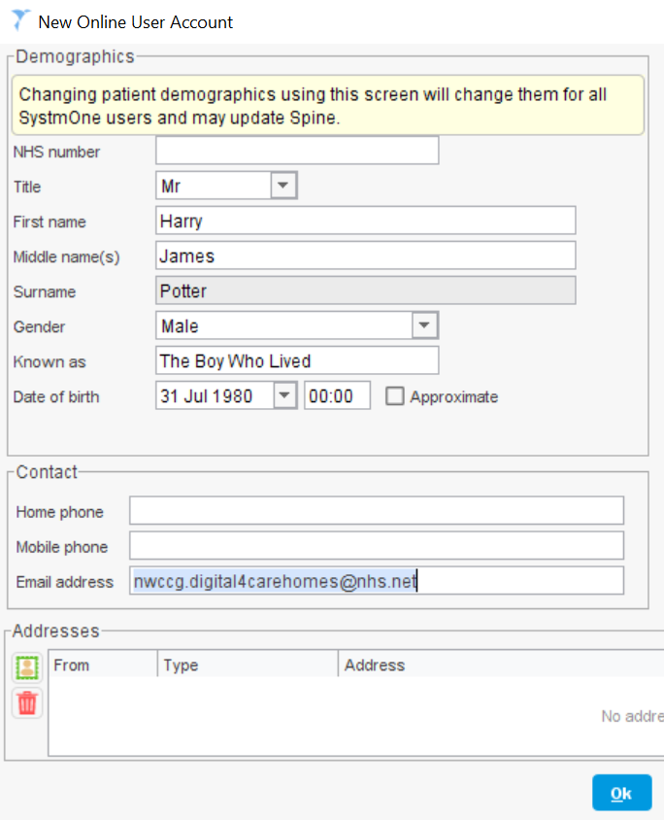
When you click Not Found this creates a new user with no previous information. You will need to input the information in the Demographics section, without an NHS number, to include a secure email address. Click the green button (as shown below) to start adding the care home address for this care home staff member.
Clicking either Not Found or Create Account for Selection will bring you to the New Online User Account > Demographics screen.
Reminder: Do NOT enter an NHS number, as it will potentially link the care home staff member with their patient profile.
Fill in all of the applicable information, to include a individual secure email.
Click the green button to start adding the care home address for this care home staff member.
The Address Type Selection box will pop up.

STEP 5

In the Address Type Selection, select Home, then an Address screen will pop up.

STEP 6
When entering the address of care home staff, you will enter the address of the care home. Fill in the Address screen that pops up. Click Ok.
Note: Entering in the postcode will help to pre-fill the Town and County.

STEP 7
In the Demographics screen the address will now show at the bottom. Click Ok.
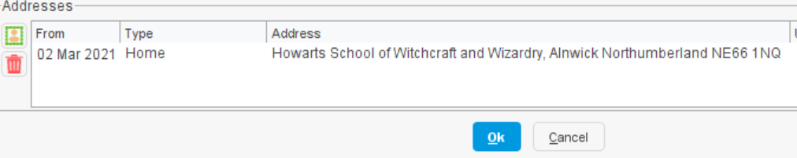
A large popout Identity Verification screen will now come up.
STEP 8
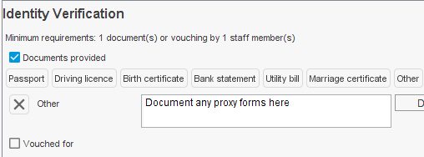
To add/document proxy access documents, this is done by ticking Documents Provided and clicking the Other tab. (instructions below)
Note: You must ensure that you have met the minimum requirement for finalisation of the care home staff member.

STEP 9
When you click Other, you will then drag a picture (JPEG, not a PDF document) in the Drag Image Here box.
Tick Vouched for after you have received and reviewed the proxy request form vouched for by the care home lead. Choose Information confirmation as you have confirmed this via the Staff Proxy Access Request Form.

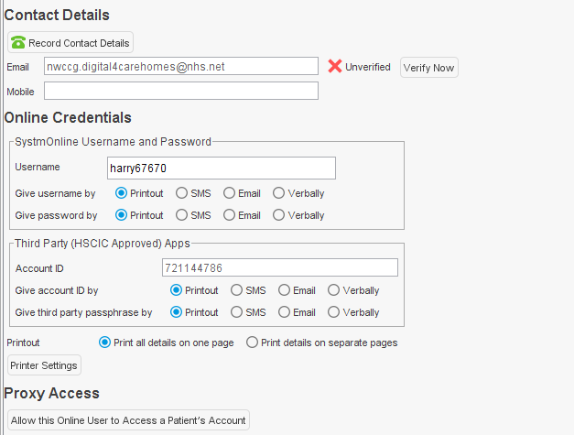
STEP 10
Under Contact Details click the green telephone icon to Record Contact Details.
A new box called Telephone Numbers & Email will pop up after Step 9 is completed.
IMPORTANT
Under the Third Party section is where the new user’s details will be sent. If you choose printout, make sure you save the printout to give to the care home staff member. If you choose Email, this will be sent to the email you entered in Contact Details.

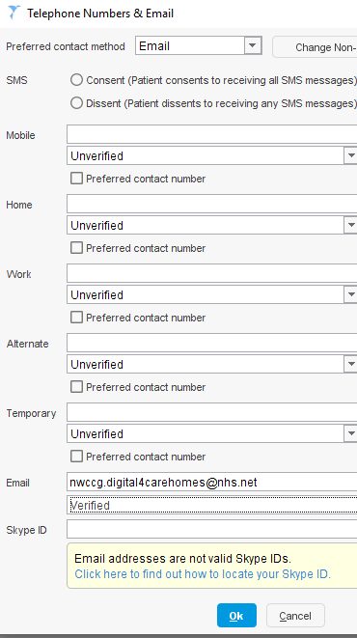
STEP 11
IMPORTANT
Ensure that Email is chosen as the Preferred contact method in the event the staff member needs to reset their password, as well as being a secure method of contact.
Enter Mobile phone number and change Unverified to Verified, so this method can be used if the staff user requires a password reset on their account.

Make certain that the care home staff member’s NHS or accredited secure email address is entered for verification details.
Choose Verified from the dropdown below the secure email. This will also ensure if the user gets locked out of their account, the reset link will go to the email linked to their account.
Click Ok.

3 Linking a staff member to a patient's / resident’s profile (new user)

You’re now going to link the care home staff member’s profile to a patient’s record with Proxy Access.

There are two ways to link a care home staff member’s profile to a patient’s record.
- You can do it directly after setting up a new user on SystmOne or you can link a staff member who already has access to SystmOne.
- If a care home staff member already has a SystmOne account and you want to link a patient/resident to an existing care home staff member’s profile, please go to Section 4.
In this section we will guide you through how to add a resident’s record to a newly created SystmOne account.

STEP 1
If you have just set up a New Online User Account for a care home staff member, the Identity Verification page will be open and you will see the Proxy Access section at the bottom.
Click Allow this Online User to Access a Patient’s Account.
Note: You will need to add one user to this account for it to save.

STEP 2
A Patients / Residents screen will pop up. Enter the patient’s / resident’s details you want to link with the care home staff member’s account.

When you find the patient that you want to link to, click Select on the bottom.

STEP 3
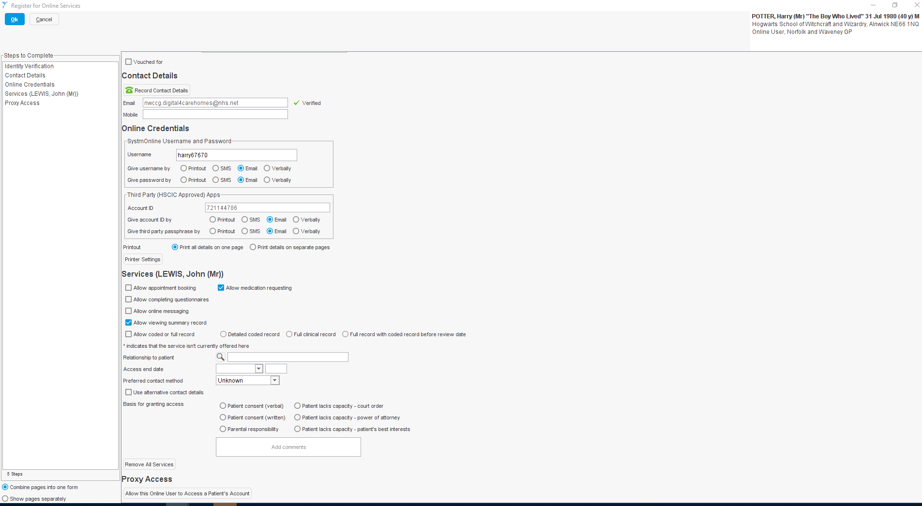
The linked account will now show on the bottom. This is evident as “Harry Potter” (the care home staff member) is at top right-hand corner. If any patients/residents are linked, it will show at the bottom left of the screen:
Proxy Users will show here
STEP 4
Before selecting the level of access you are going to give the care home staff member, be sure to review the Resident Consent Form to ensure the resident has given care home staff proxy access. Then review that the care home staff member has signed Staff Proxy Access Request Form, which is completed by the care home staff member so they can order medications for residents via proxy access.
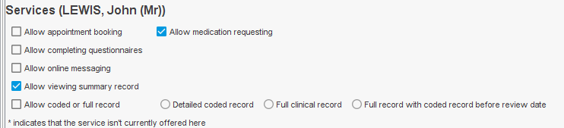
This is a more up close view of the patient /resident who the care home staff member now has proxy access to.

Select the level of access you want the care home staff member to have for the resident /patient.

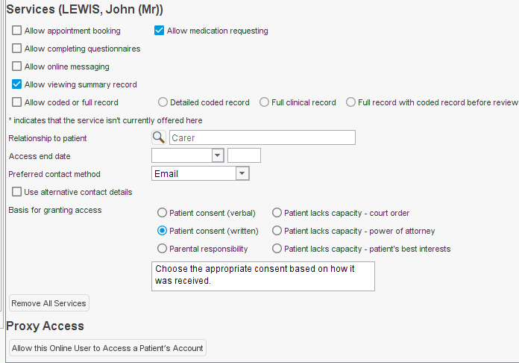
STEP 5
After choosing the level of access, then choose the Relationship to patient the care home staff member has. For this example, we’ve used ‘Carer’.
Then choose the Basis for granting access, and add comments if necessary.
If you have chosen Patient consent (written), this is where you would add the signed patient consent form.

STEP 6
If you want to assign more patients/residents to this care home staff member, then under Proxy Access, click the Allow this Online User to Access a Patient’s Account. Repeat the Steps 2 – 5 above.
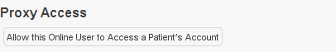

When you are finished adding patients/residents, move onto Step 7.
STEP 7
When you are finished linking the care home staff member’s account to all of the patients / residents, click Ok at the top left and a Question screen will pop up.

Note: Before clicking Ok, check on the left-hand column under Online Credentials to double check you have linked all of the residents to the proxy access user.

STEP 8
Click Inform or Don’t Inform. If you select Inform the care home staff member will receive an individual message for each resident they are linked to.

STEP 9
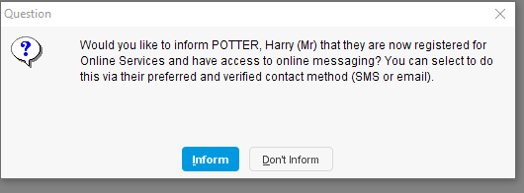
Another Question Screen may come up. Click Inform or Don’t Inform. ‘Informing’ the care home staff member will send them a message via their preferred contact method.

STEP 10
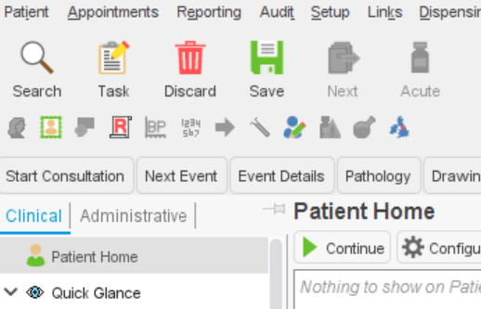
Click Save on the top left hand corner. This will send an email to the new care home staff user with their login details.

You have successfully created a new user account and linked it to a patient’s / resident’s profile.

4 Linking a staff member to a patient's / resident’s profile (existing user) at the same GP practice

You’re now going to link the care home staff member’s profile to a patient’s record with Proxy Access.

If you have a care home staff member that already has access to SystmOne and you need to link them with a new patient/resident, follow the steps below.
STEP 1
You will first need to bring up the care home staff member’s account. As the care home staff member already has an online account, they are not linked to the Spine. To search for all online users in your organisation, including online users who are not patients, select Patient > Patient Maintenance > Online Users from the Main Menu.
STEP 2

This screen will pop up and you will right click on the care home staff name you want to add proxy access to and select Retrieve Record.

If you click NHS Number, so it sorts Online Users with no NHS Number at the top, it will be easier for you to find just the Online User Accounts

STEP 3
When the below Warning screen pops up, click Ok.

STEP 4
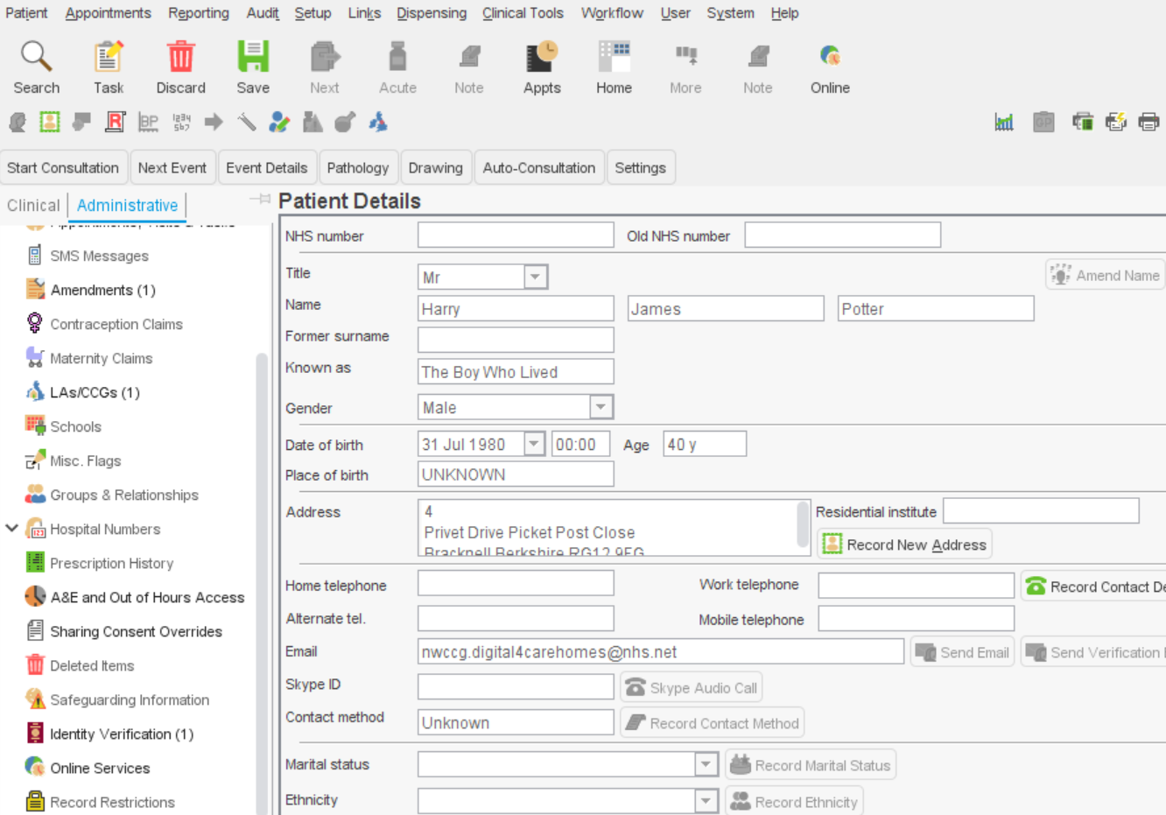
Click Administrative tree, then Online Services.

STEP 5
Click Allow access to another patient’s account.

You can also see from this screen which other care home resident’s the care home staff has access to. In Section 3, we already linked the resident (John Lewis) to the care home staff member (Harry Potter), which is why Mr Lewis is showing.

STEP 6
After clicking Allow access to another patient’s account, a Patients screen will pop up. You will now search for the new resident you want to add to the care home staff member’s profile. When you have found the additional resident, click Select.

Now you will repeat Steps 2 – 10 in Section 3.

5 Changing a user’s access rights for GP practice staff

It is very likely that there already is a designated person within the GP practice that takes care of proxy access requests for care homes within your PCN. However, if there is no one within the GP practice who takes care of these requests, it may be necessary to change the user access rights of the newly designated GP staff member. This will allow the staff member to be able to set up proxy medication online for each care home staff member and the care home residents. Other actions a System Administrator can do include:

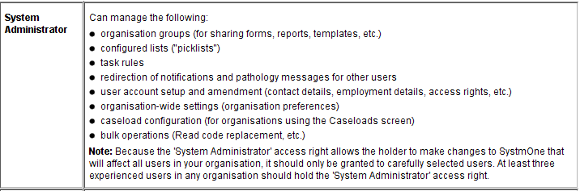

Changing a User's Access Rights
- To change an existing user's access rights:
- Select Setup > Users & Policy > Staff & Organisation Setup from the Main Menu.
- Select the relevant care home staff member from the list displayed.
- Right click Amend Staff.
- Select the Local Access Rights tab of the Amend Staff Details dialog.
- Select/deselect the tick‑box beside the access right(s) you want to grant/withhold.
- Click Ok.

The below Amend Staff Details popup will come up after you right click on the care home staff member’s name and select Amend Staff in Step 4. Click Ok to finalise your changes.

6 Removing and editing online user access

Keep in mind that if there is more than one proxy log-in issued to the care home, you may need to make these changes to the other account also.

It is the Care Home’s responsibility to notify the GP surgery when they have staff member that leaves. It is the GP surgeries responsibility to remove that staff member as soon as possible, to ensure there are no potential data breaches for any patient/resident.

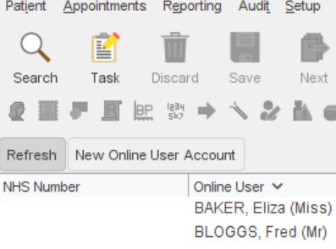
- On the top bar, go to Patient > Patient Maintenance > Online users.
- Find the proxy user. Filtering by NHS number will show proxy users at the top as they have no NHS number.
- On retrieval of the proxy user account, the online services screen should appear. If this does not open, you will need to click the ‘online services’ tab in the left administration bar.

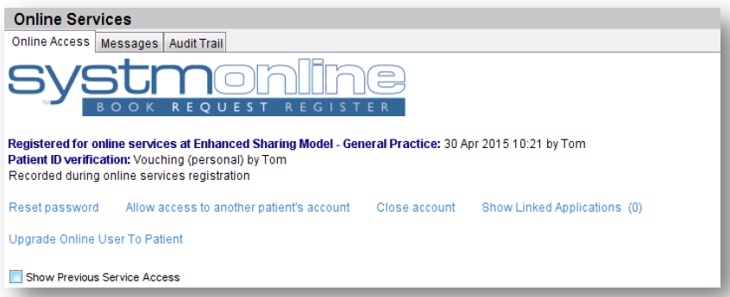

Reset Password – will reset the proxy user’s password.

Allow access to another patients account - choose this option to add further patients to a proxy user account. The care home must submit the consent paperwork before setting up online access.

Close Account - will stop proxy access to previously linked patient’s accounts. This is the function to use when a staff member with access leaves a care facility.

Removing proxy access from an individual patient:
Changing the address of an individual (e.g. left the care facility) or transfer to a different surgery should dissociate online proxy access from an individual’s account. However, as good practice we would advocate accessing the individuals record, loading ‘online services’ and removing any associated proxy users which have been set up for the care provider.

Method for removing online proxy access:

- Search for the patient via the usual ‘Search’ function.
- Access the ‘Administrative’ tab on the left panel.
- Scroll down to ‘Online services’.
- Identify the associated proxy user(s) who you want to remove and select ‘Remove access’.
- The proxy user no longer has access. 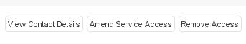

7 Resetting an Online User Account

STEP 1
You will first need to bring up the care home staff member’s account. As the care home staff member already has an online account, they are not linked to the Spine. To search for all online users in your organisation, including online users who are not patients, select Patient > Patient Maintenance > Online Users from the Main Menu.
STEP 2

This screen will pop up and you will right click on the care home staff name you want to add proxy access to and select Retrieve Record.

If you click NHS Number, so it sorts Online Users with no NHS Number at the top, it will be easier for you to find just the Online User Accounts

STEP 3
Under the Administrative tree, click Online Services.
STEP 4
You will then click Reset password/Change username. An information screen will pop up and click Ok.
STEP 5
An Identity Verification Screen will pop up.
Click Other, you will then drag a picture (JPEG, not a PDF document) in the Drag Image Here box.
Tick Vouched for after you have received and reviewed the proxy request form vouched for by the care home lead. Choose Information confirmation as you have confirmed this via the Staff Proxy Access Request Form.
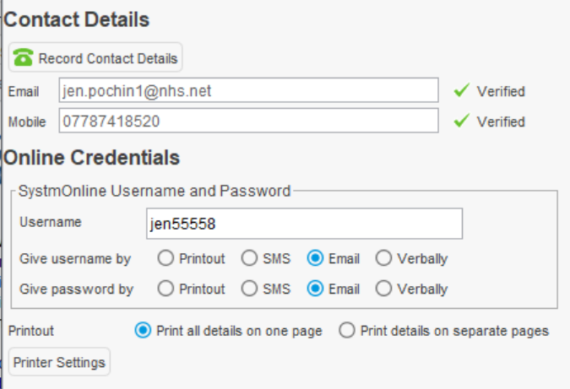
STEP 6
Mobile phone here
Ensure that NHS email is in the Email section and a mobile phone is entered.
NHS email here
A Username will be within the Online Credentials. Ensure that the Email circle is selected. Then select Ok at the bottom.
Username will be here
The Online User will have their password reset.

8 Frequently Asked Questions (FAQs)

- Do care homes have to have individual accounts for care staff?

Individual accounts must be set up for all care home staff members that are to be given proxy access for data security reasons. When you login, all the residents for that care home will be listed so they choose which resident they wish to access; this can be for more than one GP if using the same GP system (e.g. SystmOne).

- Is this proxy access for the NHS App only or all NHS approved apps?

NHS App is only for individuals and not currently recommended for care home use for ordering medications.

- What happens if care home staff are off sick, who then requests the medication for their assigned patients?

It is the care home's responsibility to have a minimum of two members of staff who can request medication and also to inform the surgery of any staff leavers or joiners.

- What patient information do care home staff have access to, just repeat template, or other clinical info?

It depends what access is given by the practice as they remain the data controller. With standard proxy access, the care home can access demographic information and medication that’s is available for order. Any further access would need to be discussed with the practice and care homes locally.

- For Care Homes with residents registered in more than one surgery, do they need more than one account? One for each practice?

No, they can have one account if all practices are on the same GP system. The GP practices will have to make a local agreement to decide who maintains the care home staff member accounts.

- With regards to verbal consent - do you have to obtain signature or write on the form "verbal consent obtained"?
Best practice advises that you must record that you have informed all the residents of the changes in process, the template can be adapted and used for this, to be discussed, agreed and recorded locally at the start of the project how this is to be addressed.
- If there were any medications not on repeat or on acute, but started by the hospital, how is that dealt with by the care home?

By a secure email to the GP practice or by phone if urgent.

- Have the number of missing items gone down under proxy ordering?

Yes, considerably.

- There is no audit trail for whether an acute medicine (outside of the normal cycle) request has been accepted or not. Is there any solution for this?

The request for an acute medication is made via a note and these are recorded on the GP system but there is no way for the practice to confirm the note has been actioned. Current process would not change to follow up any urgent issues to ring the surgery/pharmacy where needed or send an email if not urgent.

- If a care home staff member leaves the care home, what should happen?

The care home manager should notify the GP surgery immediately when and/or prior to a care home staff member leaving the care home. The GP surgery will remove the care home staff member’s proxy access for the current care home, as well as their ability to access online services for any other access they may have. You will do this in Online Services in the Administration tree, then click Remove Access under the applicable heading.

- A new care home resident has just been changed from one GP practice to our practice, but I can’t see the record on SystmOne? Why is that?

Sometimes, it takes a few days for the record to fully transfer over. You may be able to see items within the patient’s / resident’s record, but you can’t change them. Ensure that there is communication between the GP practice and the care home, and all pertinent notes are documented accordingly. If this does occur for longer than one week, please contact the SystmOne helpdesk at 01132 050095.

- When I search for a list of residents by the care home’s address, only some residents show and not others? How can I make them all show at the same time?

The reason that some residents within a care home show and not all residents is most likely because some residents have their care home address documents slightly different. To alleviate this problem, you will need to check the care home address for every resident and make sure it is exactly the same for all.

8 Points of contact for additional support

The Norfolk and Waveney CCG Digital Care Homes team is able to provide comprehensive, responsive and effective support for your digital needs. We pride ourselves in working a collaborative manner with all Care Homes, GP surgeries, Pharmacies and other NHS Trusts in the Norfolk and Waveney area to provide you with a high-quality, streamlined service.
Please contact us at nwccg.digitalsocialcare@nhs.net if you need further assistance.

9 Appendix

APPENDIX 1 – Resident Leaflet
APPENDIX 2 – Resident Consent Form
APPENDIX 3 – Staff Proxy Access Request Form
APPENDIX 4 – Staff Proxy Access Information Leaflet
APPENDIX 5 – Proxy Access for Medication Good Practice Guide
APPENDIX 6 – Full Configuration Checklist for GPs
APPENDIX 7 – Configuration Day Checklist for GPs

