

NHS Norfolk and Waveney ICB

Medicines Optimisation Team

Floor 8 County Hall

Martineau Lane

Norwich

Norfolk

NR1 2DH

<Date>

Private and Confidential

<Patient Name>

<Patient Address>

Dear **< insert patient name >**

**Important information about your repeat prescription**

In line with good clinical practice, we regularly review the medicines we prescribe to ensure that we are prescribing in line with national guidance. We have recently reviewed patients who are prescribed **vitamin B supplements** to ensure that they are only prescribed where there is clinical justification for doing so.

We have reviewed your prescription for vitamin B supplements and in line with national guidance we have switched these to.

Thiamine (insert strength here) tablets. (Insert dose here)

Thiamine is vitamin B1 and in line with national guidance it is recommended that you take this supplement. You do not require other vitamin B supplements anymore and therefore you will no longer receive your vitamin B compound tablets on prescription. Please use up any remaining vitamin B compound tablets before you order your new prescription for thiamine.

Should you require more information about this, please contact the Contact Us Team at [**nwicb.contactus@nhs.net**](mailto:nwicb.contactus@nhs.net), they will be able to put you in contact with the appropriate person.

**Yours sincerely**

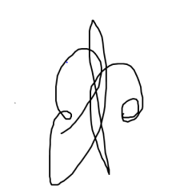

**Dr Andrew Douglass** **MBBS MRCGP**

**Specialty Advisor for Prescribing and Elective Recovery**

**NHS Norfolk and Waveney ICB**