

NHS Norfolk and Waveney ICB

Medicines Optimisation Team

Floor 8 County Hall

Martineau Lane

Norwich

Norfolk

NR1 2DH

<Date>

Private and Confidential

<Patient Name>

<Patient Address>

Dear <Patient Name>

**Mild to Moderate Hay Fever/Seasonal Rhinitis**

The local NHS, Norfolk and Waveney Integrated Care Board, regularly review the medicines prescribed to ensure that our local doctors are using the most effective and good value medicines. Following national guidance prescriptions for treatment of mild to moderate hay fever/ seasonal rhinitis should not be (routinely) prescribed in primary care as the condition is appropriate for self-care.

You are currently taking (INSERT repeat medication name); this will be removed from your repeat list and should be bought over the counter at a pharmacy or supermarket (delete as appropriate)

Any decision to change prescribing is not taken lightly; it is our responsibility to provide the best value for money for all our patients. To meet that duty, we need to make sure we commission cost-effective prescribing which will have the greatest impact on the largest number of people.

Should you require more information about this, please contact the Contact Us Team at [**nwicb.contactus@nhs.net**](mailto:nwicb.contactus@nhs.net), they will be able to put you in contact with the appropriate person.

**Yours sincerely**

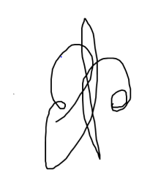

**Dr Andrew Douglass** **MBBS MRCGP**

**Specialty Advisor for Prescribing and Elective Recovery**

**NHS Norfolk and Waveney ICB**