

NHS Norfolk and Waveney ICB

Medicines Optimisation Team

Floor 8 County Hall

Martineau Lane

Norwich

Norfolk

NR1 2DH

<Date>

Private and Confidential

<Patient Name>

<Patient Address>

Dear **< insert patient name >**

**Important information about your repeat prescription for Vitamin B supplements**

In line with good clinical practice, we regularly review the medicines we prescribe to ensure that we are prescribing in line with national guidance. We have recently reviewed patients who are prescribed **vitamin B supplements** to ensure that they are only prescribed where there is clinical justification for doing so.

We have reviewed your prescription for vitamin B supplements and are pleased to inform you that you no longer need to take these, therefore we have removed them from your repeat prescription.

**There is no clinical need for you to continue to take vitamin B supplements** however some patients may decide they would like to continue taking them, if this is the case, they can be purchased from a health food shop or pharmacy.

Should you require more information about this, please contact the Contact Us Team at [**nwicb.contactus@nhs.net**](mailto:nwicb.contactus@nhs.net), they will be able to put you in contact with the appropriate person.

**Yours sincerely**

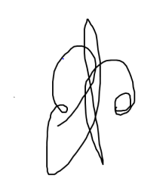

**Dr Andrew Douglass** **MBBS MRCGP**

**Specialty Advisor for Prescribing and Elective Recovery**

**NHS Norfolk and Waveney ICB**